IKEA
https://www.ikea.com/es/es/cat/juguetes-madera-18738/

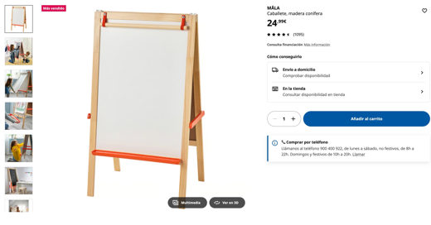
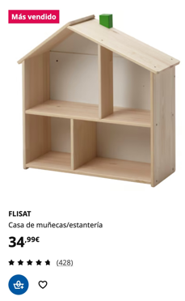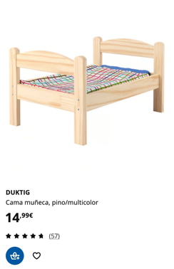

MABA
https://mabaonline.com/mobiliario-miniatura-de-madera-para-casa-de-munecas-refar07571-p-810.html
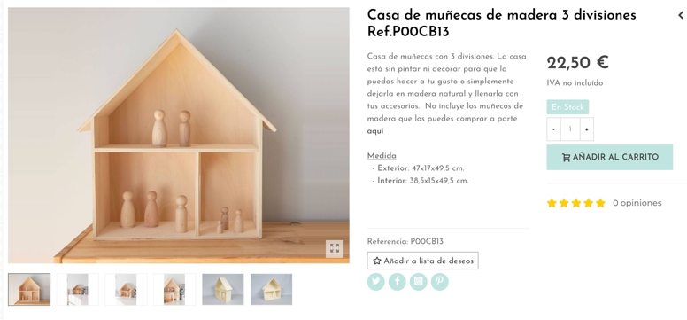

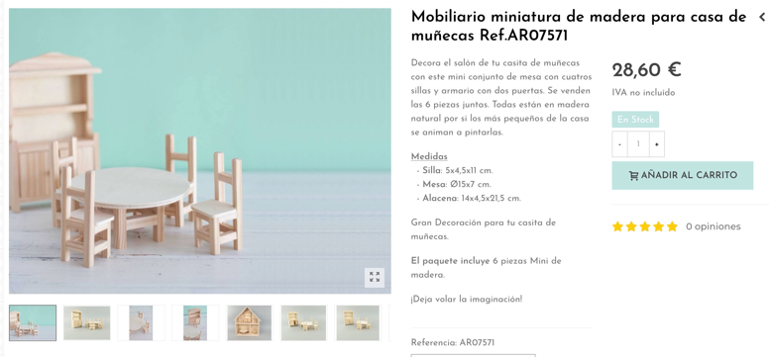
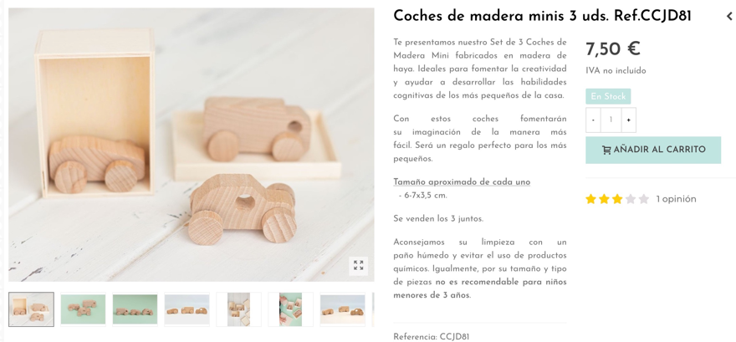
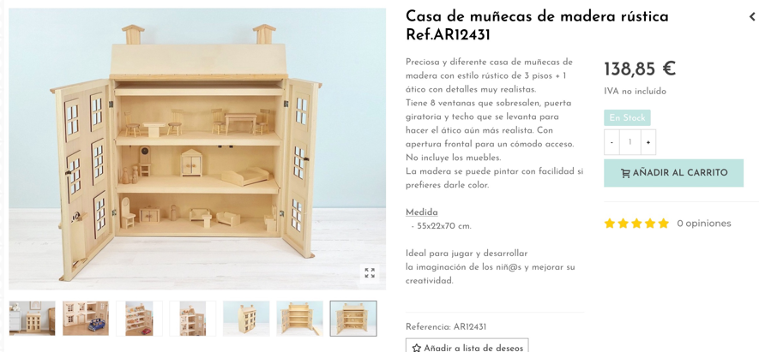
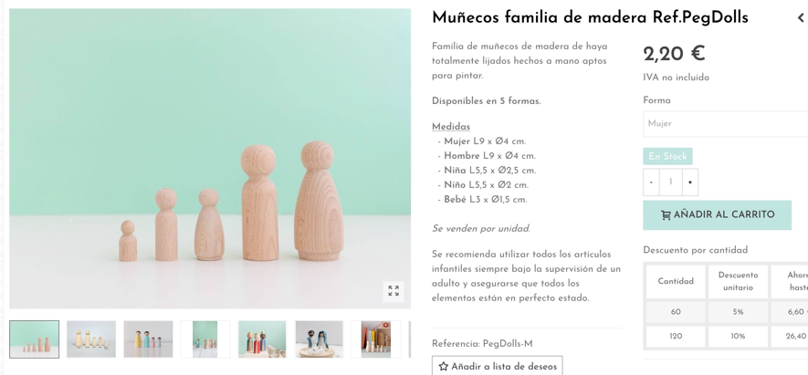

LIDL
https://www.lidl.es/es/juguetes-de-madera/c3258

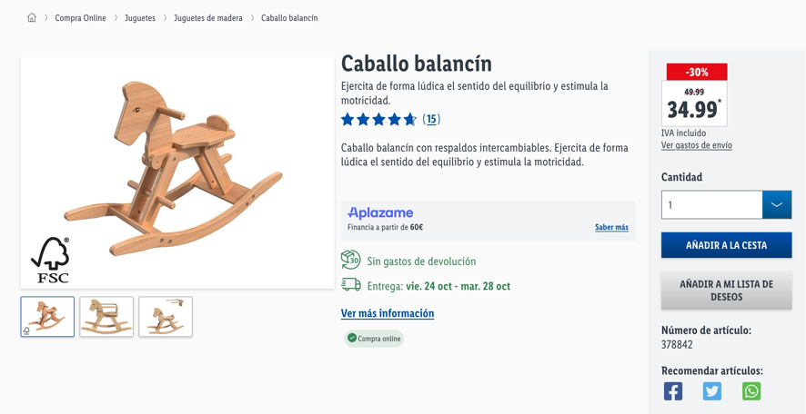

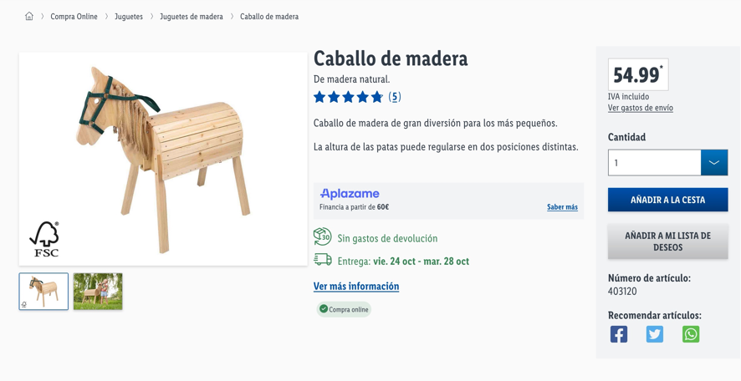

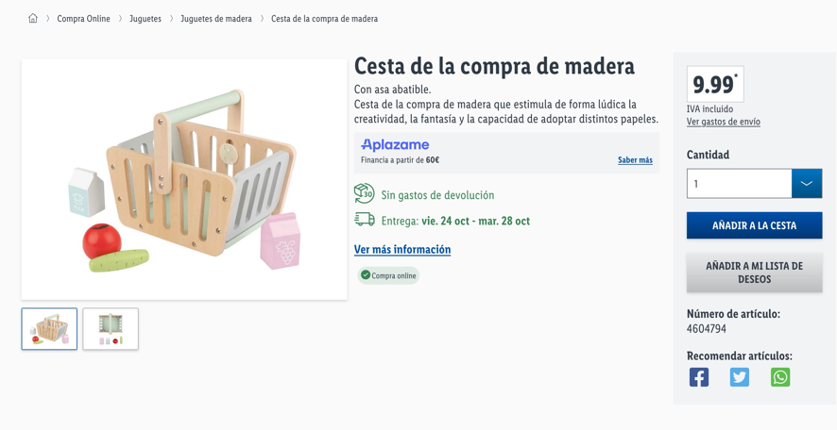
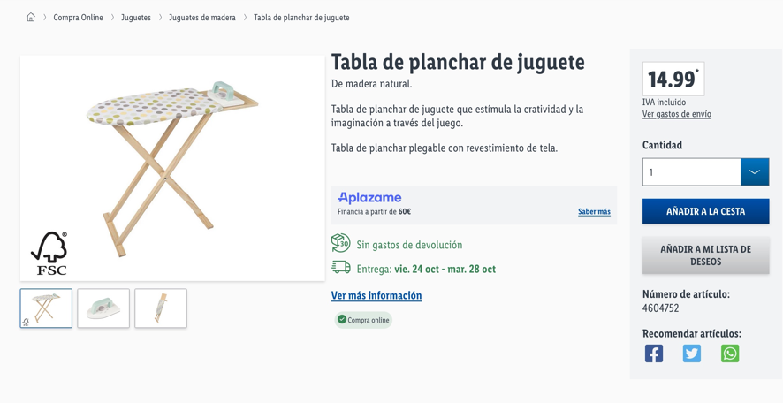
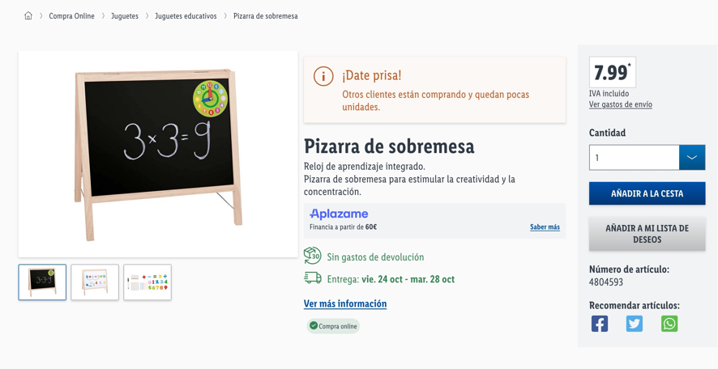
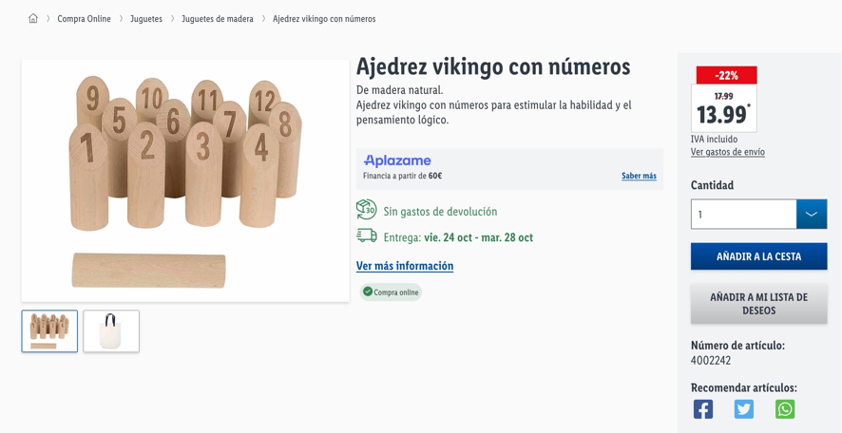
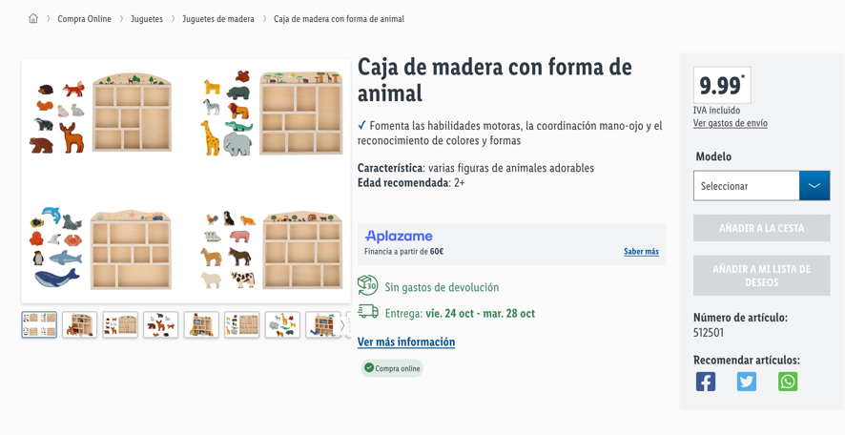
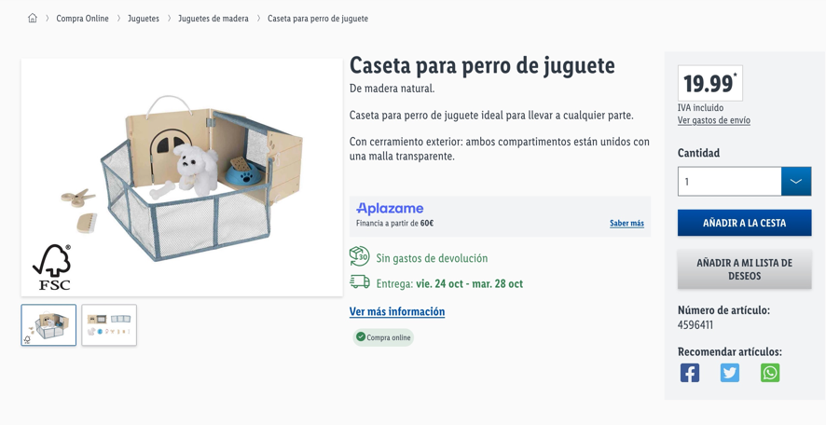

AMAZON
https://www.amazon.es/Mu%C3%B1ecas-Matrioska-Original-Juguete-EUXL360/dp/B082WQX1GJ/ref=sr_1_1_sspa?__mk_es_ES=%C3%85M%C3%85%C5%BD%C3%95%C3%91&crid=1SV33WLBLPBUI&dib=eyJ2IjoiMSJ9.kL6twmUnweUGsIswQJ2hdpsPt0NHz-ON16Af1ucKeIAF4ZUGryT6jL3E6oeFUYlAi_ECehllp7K49RP_ilt0z4WA3-zeOcoS7W1nHNnhio2dYIsuwYAKyrtxh2UGaA6cfj0CEQWDjRxYT7uHHX3O42gdpxdoO-K-o9vhW82hS14Vm0bO_IYXOB3RBW11T7xTlXGEHGpzBzeDEi_0rHC6xinRyVwv1qgpXPQ-pZO_TDDF3D2HZobHkbt7TJ6hYRTe7DO1QRjdTlz7VQJKBX7Hza2OUZ6FJuodg_4y7bucFwg.p2eLTgjLtxqZkSP9_K10rTet7t9-07f6ay-LiWz_Cig&dib_tag=se&keywords=JUGUETE+MADERA+SIN+PINTAR&qid=1761218005&sprefix=juguete+madera+sin+pintar%2Caps%2C56&sr=8-1-spons&sp_csd=d2lkZ2V0TmFtZT1zcF9hdGY&psc=1

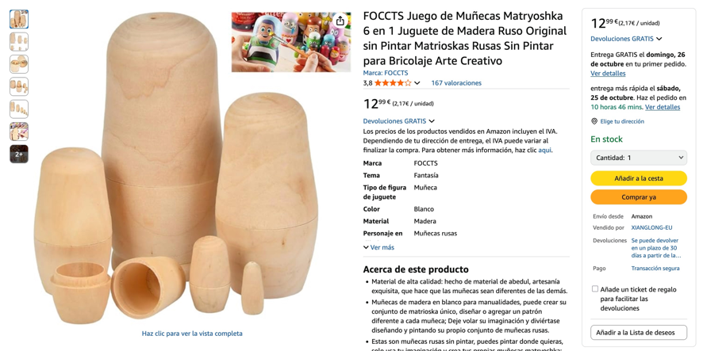

https://www.amazon.es/TNOMSNO-Terminar-Constelaciones-Familiares-Decoraci%C3%B3n/dp/B0D7QB5ZGY/ref=sr_1_4?__mk_es_ES=%C3%85M%C3%85%C5%BD%C3%95%C3%91&crid=1SV33WLBLPBUI&dib=eyJ2IjoiMSJ9.kL6twmUnweUGsIswQJ2hdpsPt0NHz-ON16Af1ucKeIAF4ZUGryT6jL3E6oeFUYlAi_ECehllp7K49RP_ilt0z4WA3-zeOcoS7W1nHNnhio2dYIsuwYAKyrtxh2UGaA6cfj0CEQWDjRxYT7uHHX3O42gdpxdoO-K-o9vhW82hS14Vm0bO_IYXOB3RBW11T7xTlXGEHGpzBzeDEi_0rHC6xinRyVwv1qgpXPQ-pZO_TDDF3D2HZobHkbt7TJ6hYRTe7DO1QRjdTlz7VQJKBX7Hza2OUZ6FJuodg_4y7bucFwg.p2eLTgjLtxqZkSP9_K10rTet7t9-07f6ay-LiWz_Cig&dib_tag=se&keywords=JUGUETE+MADERA+SIN+PINTAR&qid=1761218100&sprefix=juguete+madera+sin+pintar%2Caps%2C56&sr=8-4

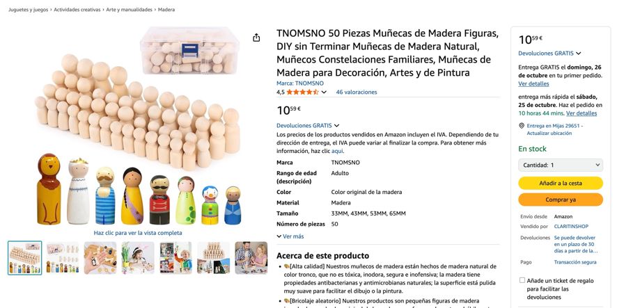

https://www.amazon.es/Creativ-Casa-mu%C3%B1ecas-para-Montar/dp/B07H41WZBQ/ref=sr_1_6?dib=eyJ2IjoiMSJ9.0KS66iQILfmRx-Hd02IXfH_nzE3I0CvFuGWNANawNZAnwv_YqT4jVsdguaKGbNtA2ZtlMzbtL9Vk3COMv8cMTjeGNjWK2tURmGcPq90TrfyMr_ZrrqZ90zvG9KF2eu-oIHHtM-SYWukbPABhIujMubHxo93Pq-g8c_GbIo_MjaXAP7oZfoyFIPMeyHyI-cF3Jovoi8oi-snuNlUgwzH4wBxshYs2g4f-vKpAZdWKZe0q4J9mcAWy2S6WzsQGZ7cTqaHuEGk-ngFBvOshLvyx4qtukrsme4dBcnJteks52N0.CpdfD6bPTMUl1eYwuzdcBaurrP-jrxK6N9JyA8RLE9o&dib_tag=se&keywords=casa+madera&qid=1761220473&sr=8-6
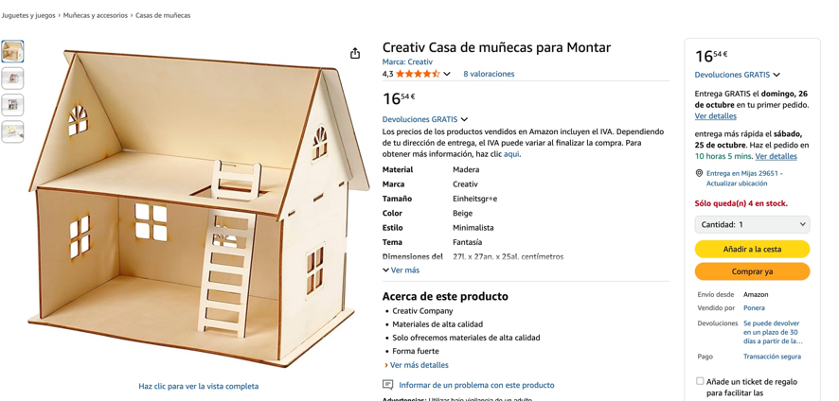

https://www.amazon.es/dormitorio-habitaci%C3%B3n-rompecabezas-manualidades-23542/dp/B0DLGHYG9H/ref=pd_bxgy_d_sccl_1/525-6698280-1605712?pd_rd_w=JyhCC&content-id=amzn1.sym.74b21e91-68d2-43e6-9bb6-b10981f45976&pf_rd_p=74b21e91-68d2-43e6-9bb6-b10981f45976&pf_rd_r=Z3NW7JZARQ54TM6VYY8B&pd_rd_wg=gnLnr&pd_rd_r=a666f1e2-8e08-4d9c-869f-f731d48d2d77&pd_rd_i=B0DLGHYG9H&psc=1

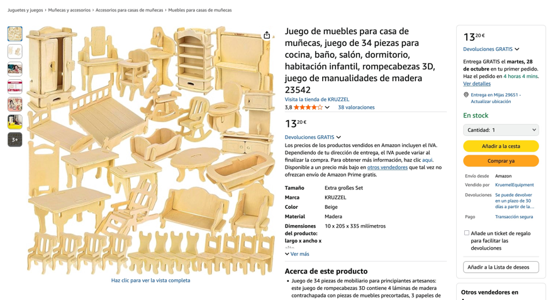

https://www.amazon.es/Pebaro-880-Casa-mu%C3%B1ecas-muebles/dp/B000TBLSCO/ref=sr_1_7?dib=eyJ2IjoiMSJ9.0KS66iQILfmRx-Hd02IXfH_nzE3I0CvFuGWNANawNZAnwv_YqT4jVsdguaKGbNtA2ZtlMzbtL9Vk3COMv8cMTjeGNjWK2tURmGcPq90TrfyMr_ZrrqZ90zvG9KF2eu-oIHHtM-SYWukbPABhIujMubHxo93Pq-g8c_GbIo_MjaXAP7oZfoyFIPMeyHyI-cF3Jovoi8oi-snuNlUgwzH4wBxshYs2g4f-vKpAZdWKZe0q4J9mcAWy2S6WzsQGZ7cTqaHuEGk-ngFBvOshLvyx4qtukrsme4dBcnJteks52N0.CpdfD6bPTMUl1eYwuzdcBaurrP-jrxK6N9JyA8RLE9o&dib_tag=se&keywords=casa+madera&qid=1761220473&sr=8-7

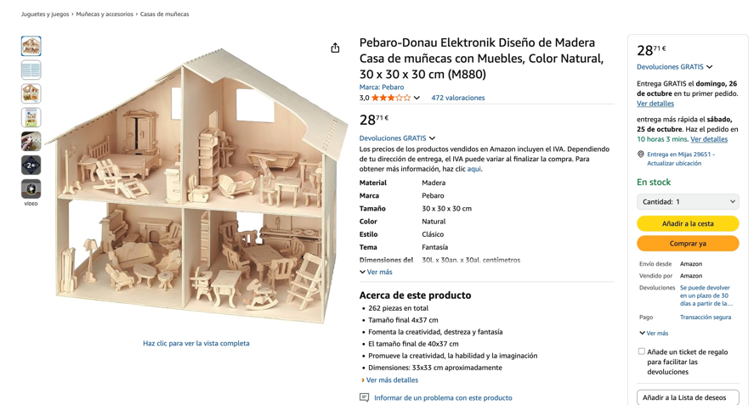

https://www.amazon.es/Hemobllo-Juguetes-Giroscopio-Manualidades-Proyectos/dp/B0FTHVG6MV/ref=sr_1_8?__mk_es_ES=%C3%85M%C3%85%C5%BD%C3%95%C3%91&crid=1SV33WLBLPBUI&dib=eyJ2IjoiMSJ9.kL6twmUnweUGsIswQJ2hdpsPt0NHz-ON16Af1ucKeIAF4ZUGryT6jL3E6oeFUYlAi_ECehllp7K49RP_ilt0z4WA3-zeOcoS7W1nHNnhio2dYIsuwYAKyrtxh2UGaA6cfj0CEQWDjRxYT7uHHX3O42gdpxdoO-K-o9vhW82hS14Vm0bO_IYXOB3RBW11T7xTlXGEHGpzBzeDEi_0rHC6xinRyVwv1qgpXPQ-pZO_TDDF3D2HZobHkbt7TJ6hYRTe7DO1QRjdTlz7VQJKBX7Hza2OUZ6FJuodg_4y7bucFwg.p2eLTgjLtxqZkSP9_K10rTet7t9-07f6ay-LiWz_Cig&dib_tag=se&keywords=JUGUETE+MADERA+SIN+PINTAR&qid=1761218100&sprefix=juguete+madera+sin+pintar%2Caps%2C56&sr=8-8
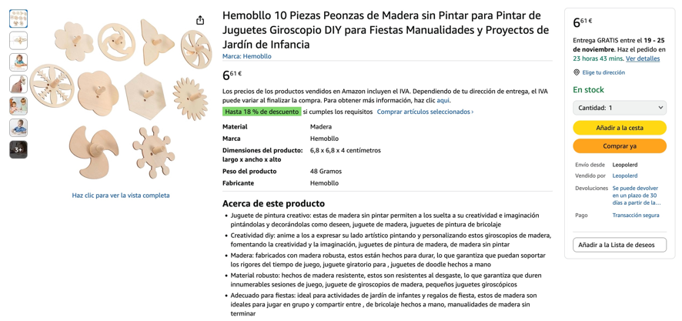

https://www.amazon.es/Cuteroom-mu%C3%B1ecas-Madera-lemogo-separada/dp/B087RCBRR1/ref=sr_1_14?dib=eyJ2IjoiMSJ9.0KS66iQILfmRx-Hd02IXfH_nzE3I0CvFuGWNANawNZAnwv_YqT4jVsdguaKGbNtA2ZtlMzbtL9Vk3COMv8cMTjeGNjWK2tURmGcPq90TrfyMr_ZrrqZ90zvG9KF2eu-oIHHtM-SYWukbPABhIujMubHxo93Pq-g8c_GbIo_MjaXAP7oZfoyFIPMeyHyI-cF3Jovoi8oi-snuNlUgwzH4wBxshYs2g4f-vKpAZdWKZe0q4J9mcAWy2S6WzsQGZ7cTqaHuEGk-ngFBvOshLvyx4qtukrsme4dBcnJteks52N0.CpdfD6bPTMUl1eYwuzdcBaurrP-jrxK6N9JyA8RLE9o&dib_tag=se&keywords=casa%2Bmadera&qid=1761220473&sr=8-14&th=1
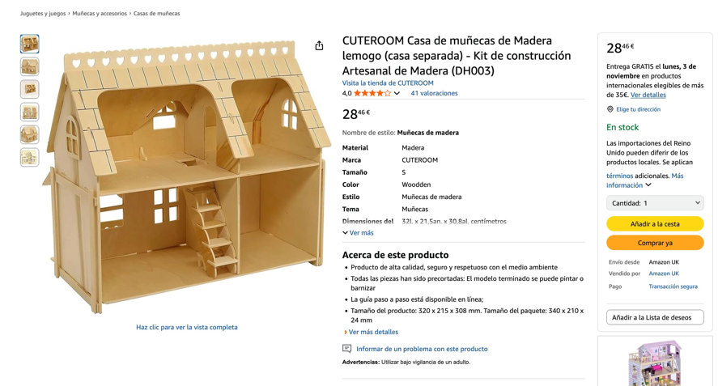

https://www.amazon.es/BOHS-1SET-34PCS-Muebles-mu%C3%B1ecas/dp/B071Z5257B/ref=pd_bxgy_d_sccl_1/525-6698280-1605712?pd_rd_w=I39Om&content-id=amzn1.sym.74b21e91-68d2-43e6-9bb6-b10981f45976&pf_rd_p=74b21e91-68d2-43e6-9bb6-b10981f45976&pf_rd_r=V5E99RAPPAMT26N3XPMP&pd_rd_wg=boMtF&pd_rd_r=626c595a-38a9-4856-a0c3-484973bc08ce&pd_rd_i=B071Z5257B&psc=1

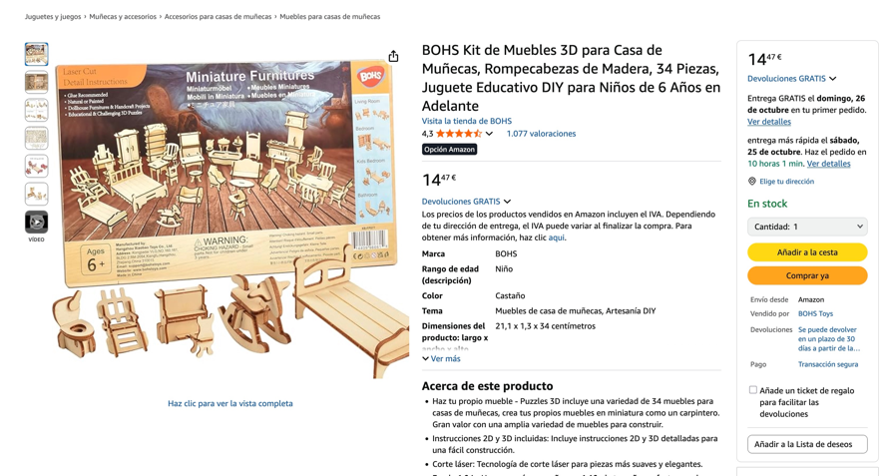

https://www.amazon.es/dp/B0D6LM2ZDB/ref=sspa_dk_detail_1?psc=1&pd_rd_i=B0D6LM2ZDB&pd_rd_w=DQ5Fu&content-id=amzn1.sym.0c640cbd-b6e0-461d-8cfc-a8934b5122df&pf_rd_p=0c640cbd-b6e0-461d-8cfc-a8934b5122df&pf_rd_r=STDAXBGCTB12TC74EW8T&pd_rd_wg=lPsqr&pd_rd_r=4d8a255c-5344-4b55-9e92-cb9dc8bc92b4&sp_csd=d2lkZ2V0TmFtZT1zcF9kZXRhaWw

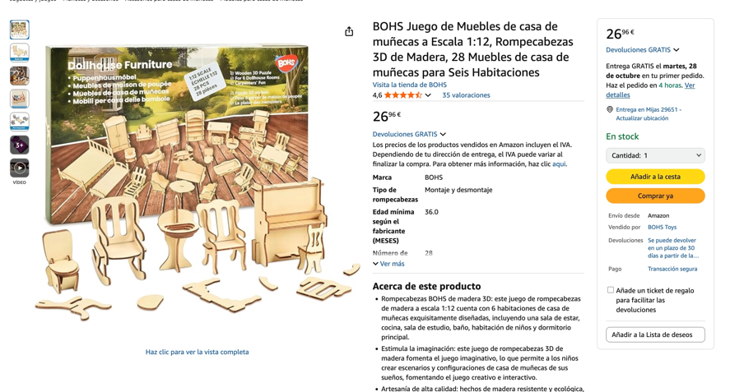
https://www.amazon.es/RUIJIE-Manualidades-Bricolaje-Dinosaurios-Herramientas/dp/B0BR5DLB91/ref=sr_1_14?__mk_es_ES=%C3%85M%C3%85%C5%BD%C3%95%C3%91&crid=1SV33WLBLPBUI&dib=eyJ2IjoiMSJ9.kL6twmUnweUGsIswQJ2hdpsPt0NHz-ON16Af1ucKeIAF4ZUGryT6jL3E6oeFUYlAi_ECehllp7K49RP_ilt0z4WA3-zeOcoS7W1nHNnhio2dYIsuwYAKyrtxh2UGaA6cfj0CEQWDjRxYT7uHHX3O42gdpxdoO-K-o9vhW82hS14Vm0bO_IYXOB3RBW11T7xTlXGEHGpzBzeDEi_0rHC6xinRyVwv1qgpXPQ-pZO_TDDF3D2HZobHkbt7TJ6hYRTe7DO1QRjdTlz7VQJKBX7Hza2OUZ6FJuodg_4y7bucFwg.p2eLTgjLtxqZkSP9_K10rTet7t9-07f6ay-LiWz_Cig&dib_tag=se&keywords=JUGUETE%2BMADERA%2BSIN%2BPINTAR&qid=1761218100&sprefix=juguete%2Bmadera%2Bsin%2Bpintar%2Caps%2C56&sr=8-14&th=1

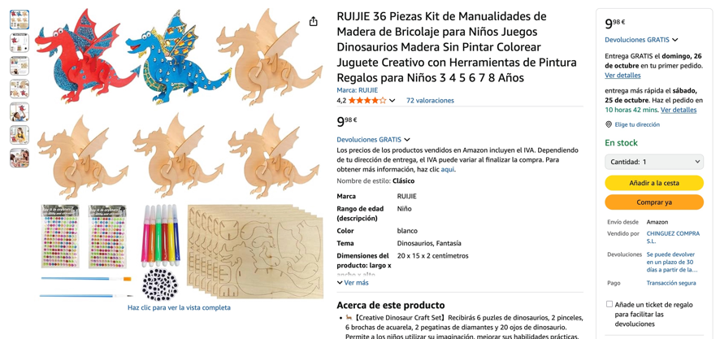

https://www.amazon.es/dp/B01CFKQJ9S/ref=sspa_dk_detail_0?pd_rd_i=B01CFKQJ9S&pd_rd_w=DQ5Fu&content-id=amzn1.sym.0c640cbd-b6e0-461d-8cfc-a8934b5122df&pf_rd_p=0c640cbd-b6e0-461d-8cfc-a8934b5122df&pf_rd_r=STDAXBGCTB12TC74EW8T&pd_rd_wg=lPsqr&pd_rd_r=4d8a255c-5344-4b55-9e92-cb9dc8bc92b4&sp_csd=d2lkZ2V0TmFtZT1zcF9kZXRhaWw&th=1

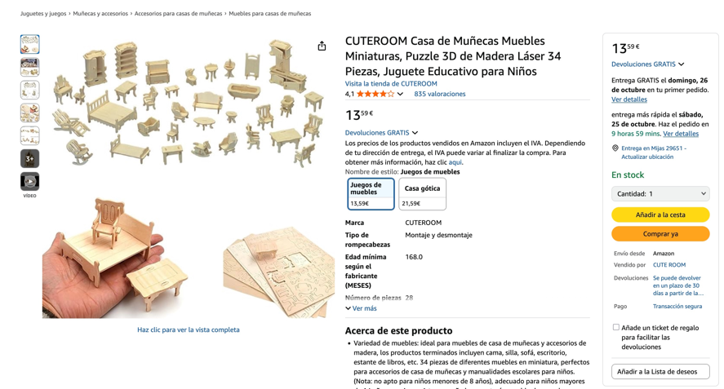

https://www.amazon.es/UPKOCH-Colgantes-Manualidades-Infantiles-Actividad/dp/B0FKZ37Z49/ref=sr_1_42?__mk_es_ES=%C3%85M%C3%85%C5%BD%C3%95%C3%91&crid=1SV33WLBLPBUI&dib=eyJ2IjoiMSJ9.kL6twmUnweUGsIswQJ2hdpsPt0NHz-ON16Af1ucKeIAF4ZUGryT6jL3E6oeFUYlAi_ECehllp7K49RP_ilt0z4WA3-zeOcoS7W1nHNnhio2dYIsuwYAKyrtxh2UGaA6cfj0CEQWDjRxYT7uHHX3O42gdpxdoO-K-o9vhW82hS14Vm0bO_IYXOB3RBW11T7xTlXGEHGpzBzeDEi_0rHC6xinRyVwv1qgpXPQ-pZO_TDDF3D2HZobHkbt7TJ6hYRTe7DO1QRjdTlz7VQJKBX7Hza2OUZ6FJuodg_4y7bucFwg.p2eLTgjLtxqZkSP9_K10rTet7t9-07f6ay-LiWz_Cig&dib_tag=se&keywords=JUGUETE+MADERA+SIN+PINTAR&qid=1761218100&sprefix=juguete+madera+sin+pintar%2Caps%2C56&sr=8-42
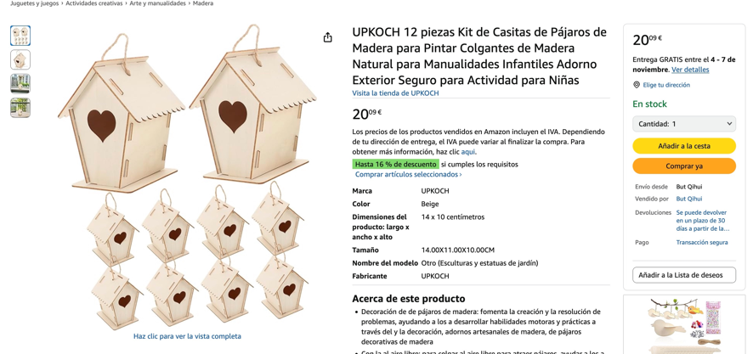

https://www.amazon.es/SafeCore-Pegamento-Elementos-contrachapado-Pinceles/dp/B0CWPFP1GQ/ref=sr_1_5?__mk_es_ES=%C3%85M%C3%85%C5%BD%C3%95%C3%91&crid=2ND36WYLW5I51&dib=eyJ2IjoiMSJ9.kopM75xoR6KRC4_b1pCkCdOpWvWrKiCUu_b-i34uZuodr_TejQFpzVtxBd_KzsS8U-9RU4rPZq6_kCEoxal6Jrj9zzr0qicMZD9iiofeX8jBxmNWHOPGNuBvXdu1RteVdsyfbwmM2RJiRYLi7no42BNzDyshWLm3haIte_ouYeD1LUIZ0LGR2lGDDdOFOtYIOX4YwiEm8hb0j8nZfmH2X4Wisr3pQ4pU-mOrWUAutpWIgjhrzs7pmVszETo4R77jPgh5E5hB8YfFRFa_pUcC6uNa0zoVMzHKbUXIapqEOkA.01adCpfCI_wv_39ri0nMaQ_8BggWqBuwUAaONA8SHlA&dib_tag=se&keywords=casa%2Bmu%C3%B1eca%2Bmadera%2Bsin%2Bpintar&qid=1761220879&s=toys&sprefix=casa%2Bmu%C3%B1eca%2Bmadera%2Bsin%2Bpintar%2Ctoys%2C48&sr=1-5&th=1

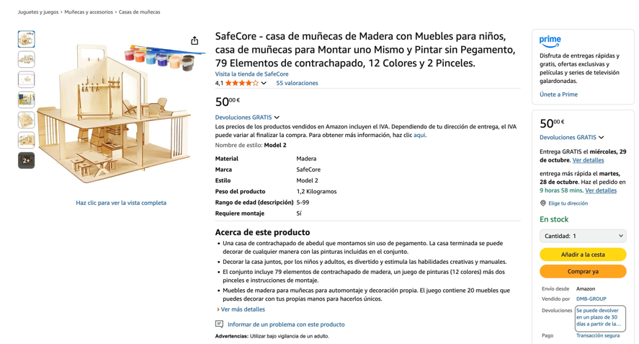

https://www.amazon.es/p%C3%A1jaros-Manualidades-creativas-perfectas-personalizar/dp/B00HU4LLU2/ref=sr_1_16?__mk_es_ES=%C3%85M%C3%85%C5%BD%C3%95%C3%91&crid=1SV33WLBLPBUI&dib=eyJ2IjoiMSJ9.kL6twmUnweUGsIswQJ2hdpsPt0NHz-ON16Af1ucKeIAF4ZUGryT6jL3E6oeFUYlAi_ECehllp7K49RP_ilt0z4WA3-zeOcoS7W1nHNnhio2dYIsuwYAKyrtxh2UGaA6cfj0CEQWDjRxYT7uHHX3O42gdpxdoO-K-o9vhW82hS14Vm0bO_IYXOB3RBW11T7xTlXGEHGpzBzeDEi_0rHC6xinRyVwv1qgpXPQ-pZO_TDDF3D2HZobHkbt7TJ6hYRTe7DO1QRjdTlz7VQJKBX7Hza2OUZ6FJuodg_4y7bucFwg.p2eLTgjLtxqZkSP9_K10rTet7t9-07f6ay-LiWz_Cig&dib_tag=se&keywords=JUGUETE+MADERA+SIN+PINTAR&qid=1761218100&sprefix=juguete+madera+sin+pintar%2Caps%2C56&sr=8-16
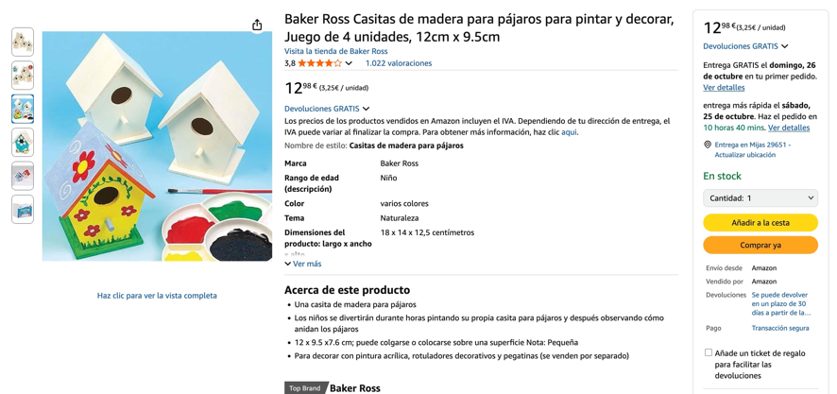

https://www.amazon.es/Baker-Ross-FN199-Construye-mu%C3%B1ecas/dp/B0DB66NP2R/ref=sr_1_24?__mk_es_ES=%C3%85M%C3%85%C5%BD%C3%95%C3%91&crid=2ND36WYLW5I51&dib=eyJ2IjoiMSJ9.kopM75xoR6KRC4_b1pCkCdOpWvWrKiCUu_b-i34uZuodr_TejQFpzVtxBd_KzsS8U-9RU4rPZq6_kCEoxal6Jrj9zzr0qicMZD9iiofeX8jBxmNWHOPGNuBvXdu1RteVdsyfbwmM2RJiRYLi7no42BNzDyshWLm3haIte_ouYeD1LUIZ0LGR2lGDDdOFOtYIOX4YwiEm8hb0j8nZfmH2X4Wisr3pQ4pU-mOrWUAutpWIgjhrzs7pmVszETo4R77jPgh5E5hB8YfFRFa_pUcC6uNa0zoVMzHKbUXIapqEOkA.01adCpfCI_wv_39ri0nMaQ_8BggWqBuwUAaONA8SHlA&dib_tag=se&keywords=casa+mu%C3%B1eca+madera+sin+pintar&qid=1761220879&s=toys&sprefix=casa+mu%C3%B1eca+madera+sin+pintar%2Ctoys%2C48&sr=1-24

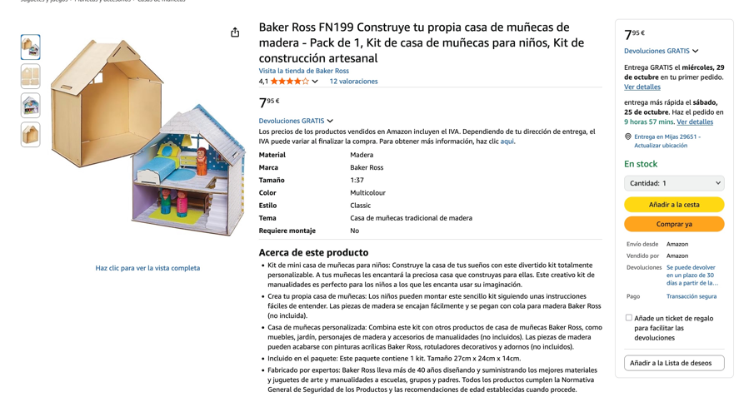

https://www.amazon.es/Miyobing-Marionetas-humanoides-artesanales-Manualidades/dp/B09PQ99RJM/ref=sr_1_25?__mk_es_ES=%C3%85M%C3%85%C5%BD%C3%95%C3%91&crid=1SV33WLBLPBUI&dib=eyJ2IjoiMSJ9.kL6twmUnweUGsIswQJ2hdpsPt0NHz-ON16Af1ucKeIAF4ZUGryT6jL3E6oeFUYlAi_ECehllp7K49RP_ilt0z4WA3-zeOcoS7W1nHNnhio2dYIsuwYAKyrtxh2UGaA6cfj0CEQWDjRxYT7uHHX3O42gdpxdoO-K-o9vhW82hS14Vm0bO_IYXOB3RBW11T7xTlXGEHGpzBzeDEi_0rHC6xinRyVwv1qgpXPQ-pZO_TDDF3D2HZobHkbt7TJ6hYRTe7DO1QRjdTlz7VQJKBX7Hza2OUZ6FJuodg_4y7bucFwg.p2eLTgjLtxqZkSP9_K10rTet7t9-07f6ay-LiWz_Cig&dib_tag=se&keywords=JUGUETE+MADERA+SIN+PINTAR&qid=1761218100&sprefix=juguete+madera+sin+pintar%2Caps%2C56&sr=8-25
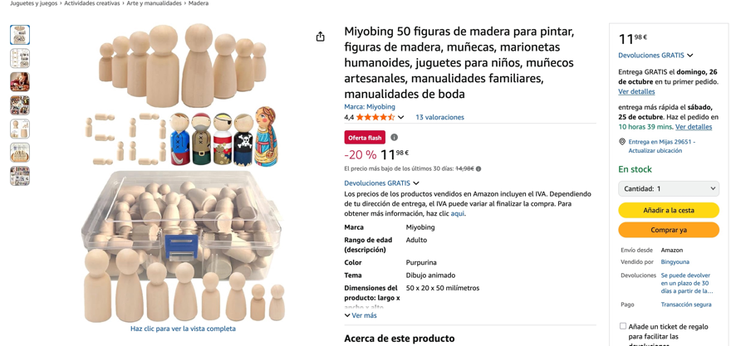

https://www.amazon.es/dp/B0DB63P5G3/ref=sspa_dk_detail_1?psc=1&pd_rd_i=B0DB63P5G3&pd_rd_w=0QcXQ&content-id=amzn1.sym.0c640cbd-b6e0-461d-8cfc-a8934b5122df&pf_rd_p=0c640cbd-b6e0-461d-8cfc-a8934b5122df&pf_rd_r=EXC3SD4QM117XJKT467S&pd_rd_wg=ycizB&pd_rd_r=a7884093-47f4-4bef-ac89-b32504bab026&s=toys&sp_csd=d2lkZ2V0TmFtZT1zcF9kZXRhaWw

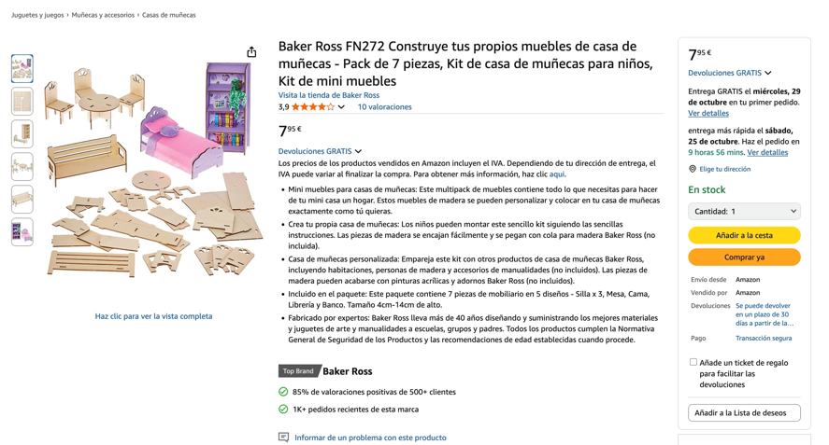

https://www.amazon.es/iplusmile-Transporte-Manualidades-Decoraci%C3%B3n-Educativos/dp/B0FLHJQJ9N/ref=sr_1_38?__mk_es_ES=%C3%85M%C3%85%C5%BD%C3%95%C3%91&crid=1SV33WLBLPBUI&dib=eyJ2IjoiMSJ9.kL6twmUnweUGsIswQJ2hdpsPt0NHz-ON16Af1ucKeIAF4ZUGryT6jL3E6oeFUYlAi_ECehllp7K49RP_ilt0z4WA3-zeOcoS7W1nHNnhio2dYIsuwYAKyrtxh2UGaA6cfj0CEQWDjRxYT7uHHX3O42gdpxdoO-K-o9vhW82hS14Vm0bO_IYXOB3RBW11T7xTlXGEHGpzBzeDEi_0rHC6xinRyVwv1qgpXPQ-pZO_TDDF3D2HZobHkbt7TJ6hYRTe7DO1QRjdTlz7VQJKBX7Hza2OUZ6FJuodg_4y7bucFwg.p2eLTgjLtxqZkSP9_K10rTet7t9-07f6ay-LiWz_Cig&dib_tag=se&keywords=JUGUETE+MADERA+SIN+PINTAR&qid=1761218100&sprefix=juguete+madera+sin+pintar%2Caps%2C56&sr=8-38
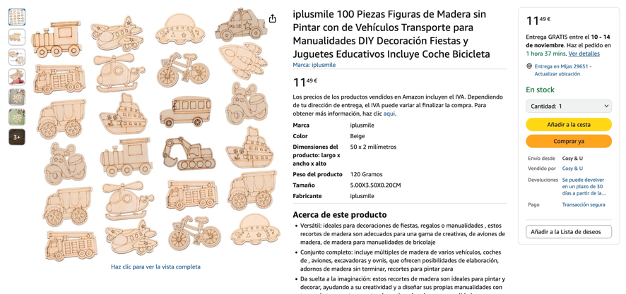

https://www.amazon.es/dp/B0B4311X7J/ref=sspa_dk_detail_3?psc=1&pd_rd_i=B0B4311X7J&pd_rd_w=NSe3h&content-id=amzn1.sym.0c640cbd-b6e0-461d-8cfc-a8934b5122df&pf_rd_p=0c640cbd-b6e0-461d-8cfc-a8934b5122df&pf_rd_r=8AWG5W4SNPGT6W5FE2Z0&pd_rd_wg=hjmMb&pd_rd_r=b39a71af-dac7-49eb-8ba4-1609f6898791&s=toys&sp_csd=d2lkZ2V0TmFtZT1zcF9kZXRhaWw

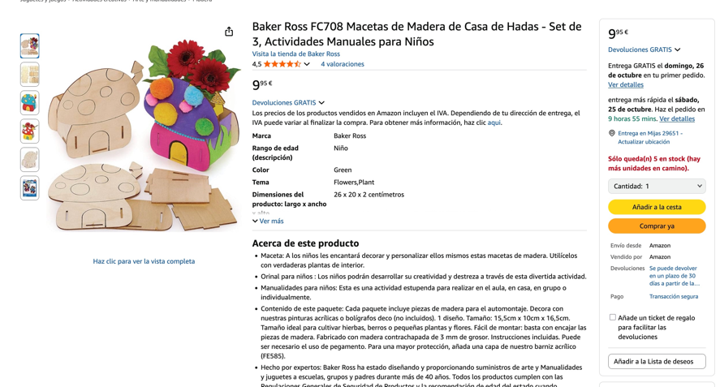
https://www.amazon.es/Annickee-Terminar-Bricolaje-almacenamiento-pigmentos/dp/B0D9XCHV8T/ref=sr_1_49?__mk_es_ES=%C3%85M%C3%85%C5%BD%C3%95%C3%91&crid=1SV33WLBLPBUI&dib=eyJ2IjoiMSJ9.kL6twmUnweUGsIswQJ2hdpsPt0NHz-ON16Af1ucKeIAF4ZUGryT6jL3E6oeFUYlAi_ECehllp7K49RP_ilt0z4WA3-zeOcoS7W1nHNnhio2dYIsuwYAKyrtxh2UGaA6cfj0CEQWDjRxYT7uHHX3O42gdpxdoO-K-o9vhW82hS14Vm0bO_IYXOB3RBW11T7xTlXGEHGpzBzeDEi_0rHC6xinRyVwv1qgpXPQ-pZO_TDDF3D2HZobHkbt7TJ6hYRTe7DO1QRjdTlz7VQJKBX7Hza2OUZ6FJuodg_4y7bucFwg.p2eLTgjLtxqZkSP9_K10rTet7t9-07f6ay-LiWz_Cig&dib_tag=se&keywords=JUGUETE+MADERA+SIN+PINTAR&qid=1761218100&sprefix=juguete+madera+sin+pintar%2Caps%2C56&sr=8-49
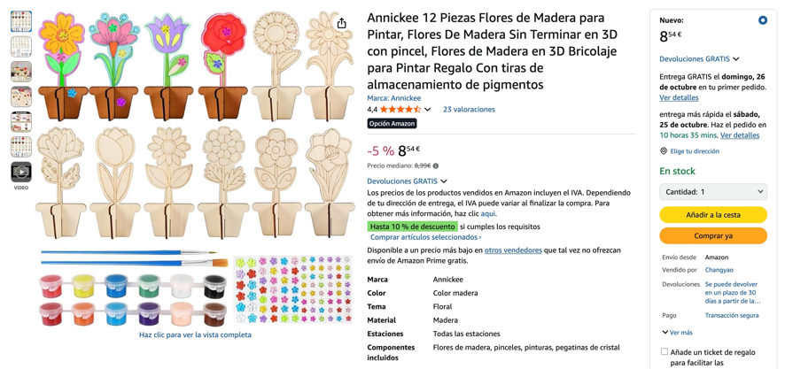

https://www.amazon.es/dp/B096G8J7B9/ref=sspa_dk_detail_1?psc=1&pd_rd_i=B096G8J7B9&pd_rd_w=J2O7y&content-id=amzn1.sym.0c640cbd-b6e0-461d-8cfc-a8934b5122df&pf_rd_p=0c640cbd-b6e0-461d-8cfc-a8934b5122df&pf_rd_r=Y50BSVEF4MQTTPF27NQG&pd_rd_wg=fBiVj&pd_rd_r=17cef892-45aa-4f2f-a535-9f8020484184&s=toys&sp_csd=d2lkZ2V0TmFtZT1zcF9kZXRhaWw

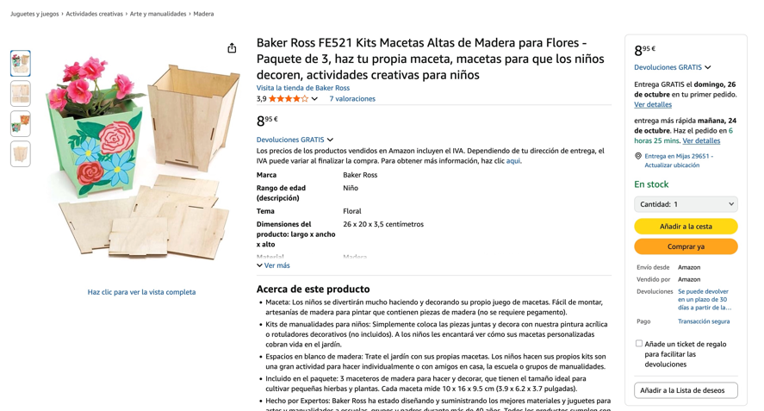

https://www.amazon.es/dp/B09FQD1YZX/ref=sspa_dk_detail_2?psc=1&pd_rd_i=B09FQD1YZX&pd_rd_w=J2O7y&content-id=amzn1.sym.0c640cbd-b6e0-461d-8cfc-a8934b5122df&pf_rd_p=0c640cbd-b6e0-461d-8cfc-a8934b5122df&pf_rd_r=Y50BSVEF4MQTTPF27NQG&pd_rd_wg=fBiVj&pd_rd_r=17cef892-45aa-4f2f-a535-9f8020484184&s=toys&sp_csd=d2lkZ2V0TmFtZT1zcF9kZXRhaWw

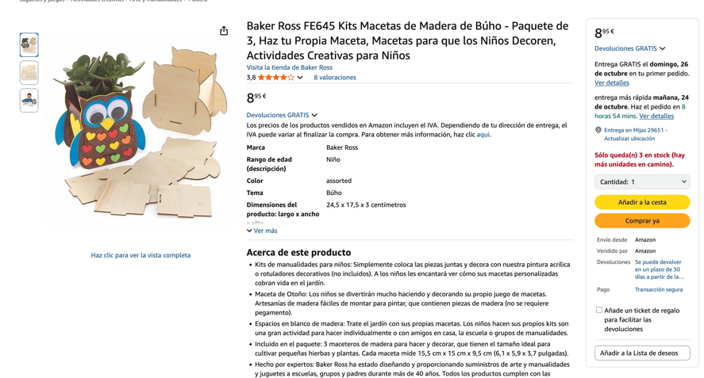

https://www.amazon.es/dp/B0B4PH6TKN/ref=sspa_dk_detail_3?psc=1&pd_rd_i=B0B4PH6TKN&pd_rd_w=J2O7y&content-id=amzn1.sym.0c640cbd-b6e0-461d-8cfc-a8934b5122df&pf_rd_p=0c640cbd-b6e0-461d-8cfc-a8934b5122df&pf_rd_r=Y50BSVEF4MQTTPF27NQG&pd_rd_wg=fBiVj&pd_rd_r=17cef892-45aa-4f2f-a535-9f8020484184&s=toys&sp_csd=d2lkZ2V0TmFtZT1zcF9kZXRhaWw

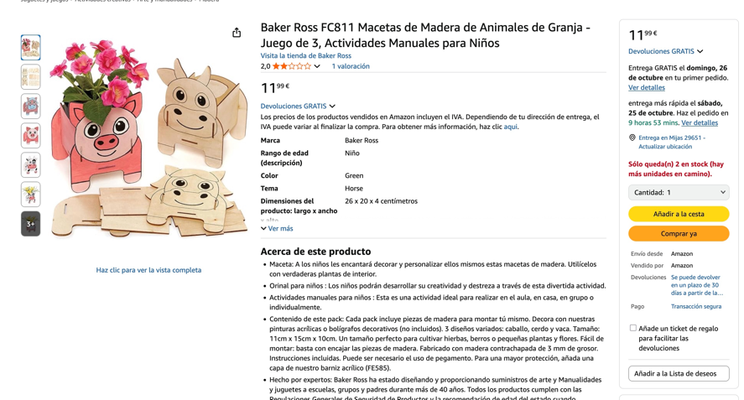

https://www.amazon.es/dp/B0B431HNJC/ref=sspa_dk_detail_3?psc=1&pd_rd_i=B0B431HNJC&pd_rd_w=SraG9&content-id=amzn1.sym.0c640cbd-b6e0-461d-8cfc-a8934b5122df&pf_rd_p=0c640cbd-b6e0-461d-8cfc-a8934b5122df&pf_rd_r=VCE07ANCR5822HVMNSJK&pd_rd_wg=bvRVU&pd_rd_r=4661c5bd-0afa-44f0-84ad-fcaaeec01feb&s=toys&sp_csd=d2lkZ2V0TmFtZT1zcF9kZXRhaWw

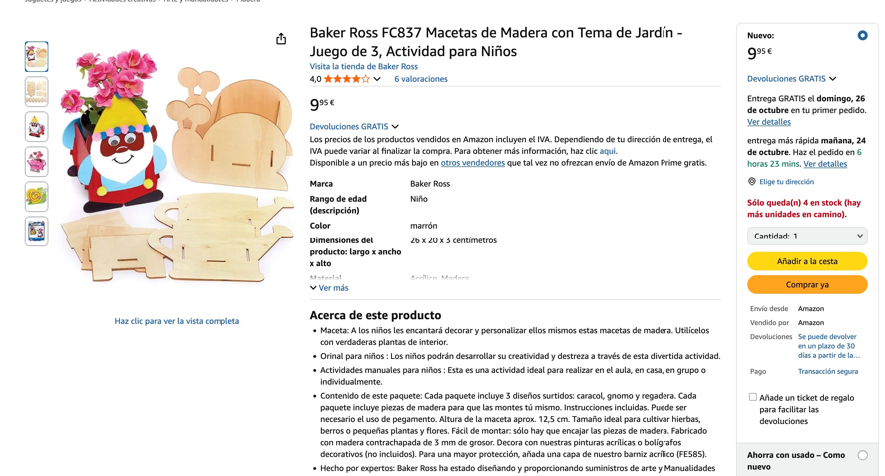

https://www.amazon.es/dp/B08259BD9R/ref=sspa_dk_detail_0?psc=1&pf_rd_p=0c640cbd-b6e0-461d-8cfc-a8934b5122df&pf_rd_r=C1Z446F06AT58C6J21QQ&pd_rd_wg=Tw5Ae&pd_rd_w=CpFA1&content-id=amzn1.sym.0c640cbd-b6e0-461d-8cfc-a8934b5122df&pd_rd_r=067c852d-c4d8-4275-be72-ecc01ef31ee5&s=toys&sp_csd=d2lkZ2V0TmFtZT1zcF9kZXRhaWw

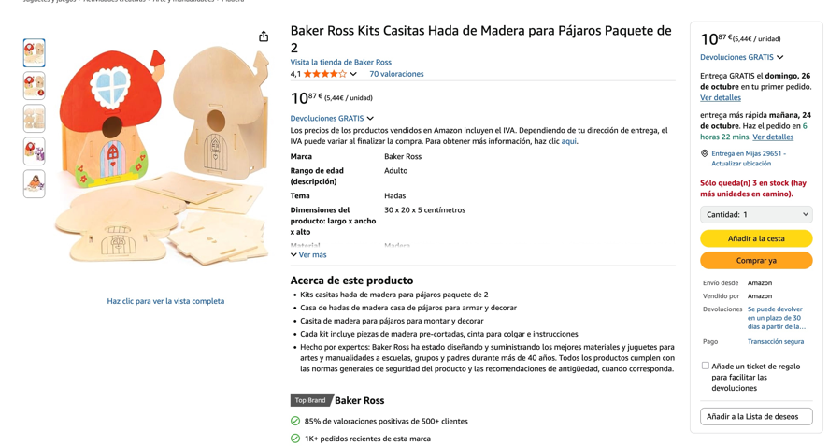

https://www.amazon.es/dp/B07M92WMQT/ref=sspa_dk_detail_3?psc=1&pf_rd_p=0c640cbd-b6e0-461d-8cfc-a8934b5122df&pf_rd_r=C1Z446F06AT58C6J21QQ&pd_rd_wg=Tw5Ae&pd_rd_w=CpFA1&content-id=amzn1.sym.0c640cbd-b6e0-461d-8cfc-a8934b5122df&pd_rd_r=067c852d-c4d8-4275-be72-ecc01ef31ee5&s=toys&sp_csd=d2lkZ2V0TmFtZT1zcF9kZXRhaWw

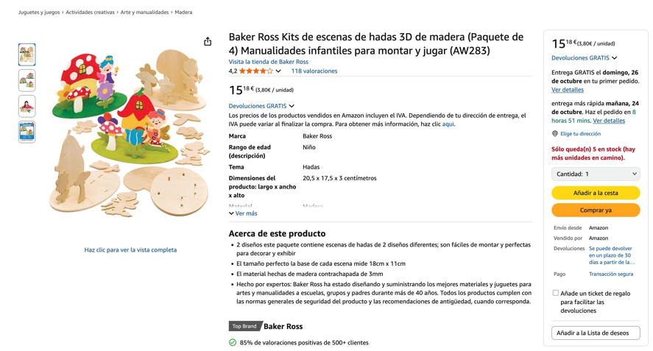

https://www.amazon.es/dp/B087N9CWNK/ref=sspa_dk_detail_0?psc=1&pf_rd_p=0c640cbd-b6e0-461d-8cfc-a8934b5122df&pf_rd_r=C3B8Q2XP5PQ2F4WFXB4R&pd_rd_wg=gXUhk&pd_rd_w=VQDah&content-id=amzn1.sym.0c640cbd-b6e0-461d-8cfc-a8934b5122df&pd_rd_r=7d15502a-380e-47ce-aa74-9554d06aaed2&s=toys&sp_csd=d2lkZ2V0TmFtZT1zcF9kZXRhaWw

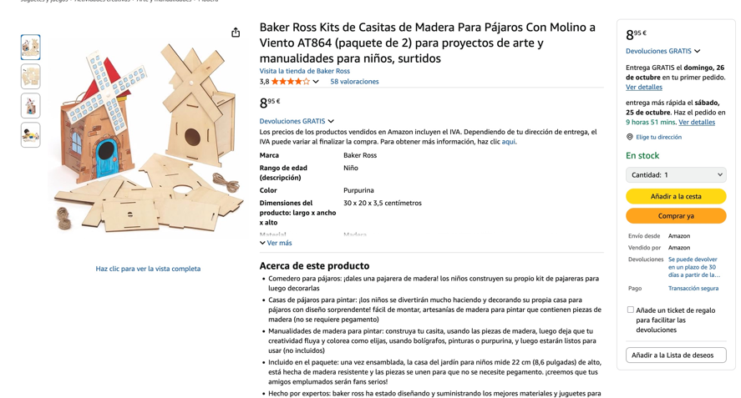

https://www.amazon.es/dp/B0D433JHS4/ref=sspa_dk_detail_2?pd_rd_i=B0D433JHS4&pd_rd_w=SBIHC&content-id=amzn1.sym.0c640cbd-b6e0-461d-8cfc-a8934b5122df&pf_rd_p=0c640cbd-b6e0-461d-8cfc-a8934b5122df&pf_rd_r=0PCPESKF89RXAE6TVM5P&pd_rd_wg=eOAgI&pd_rd_r=a97ebd5e-7a82-4efe-b889-97521e8a151e&s=toys&sp_csd=d2lkZ2V0TmFtZT1zcF9kZXRhaWw&th=1

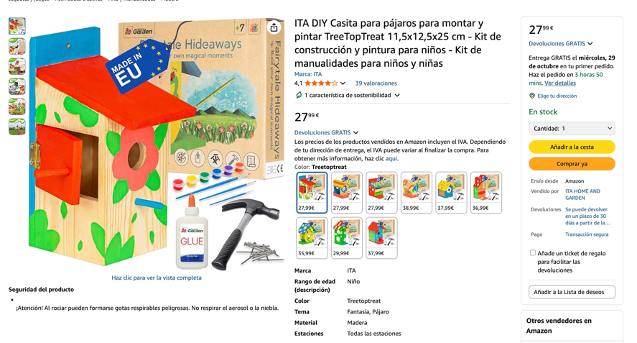

https://www.amazon.es/dp/B087N5T7ZN/ref=sspa_dk_detail_3?psc=1&pd_rd_i=B087N5T7ZN&pd_rd_w=SBIHC&content-id=amzn1.sym.0c640cbd-b6e0-461d-8cfc-a8934b5122df&pf_rd_p=0c640cbd-b6e0-461d-8cfc-a8934b5122df&pf_rd_r=0PCPESKF89RXAE6TVM5P&pd_rd_wg=eOAgI&pd_rd_r=a97ebd5e-7a82-4efe-b889-97521e8a151e&s=toys&sp_csd=d2lkZ2V0TmFtZT1zcF9kZXRhaWw

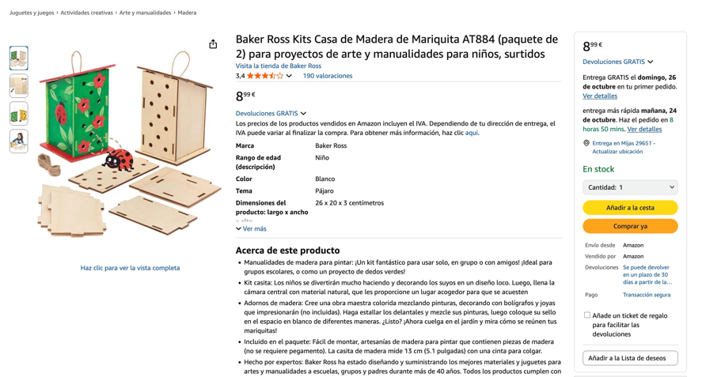

https://www.amazon.es/dp/B088H6XJFK/ref=sspa_dk_detail_4?psc=1&pd_rd_i=B088H6XJFK&pd_rd_w=SBIHC&content-id=amzn1.sym.0c640cbd-b6e0-461d-8cfc-a8934b5122df&pf_rd_p=0c640cbd-b6e0-461d-8cfc-a8934b5122df&pf_rd_r=0PCPESKF89RXAE6TVM5P&pd_rd_wg=eOAgI&pd_rd_r=a97ebd5e-7a82-4efe-b889-97521e8a151e&s=toys&sp_csd=d2lkZ2V0TmFtZT1zcF9kZXRhaWw

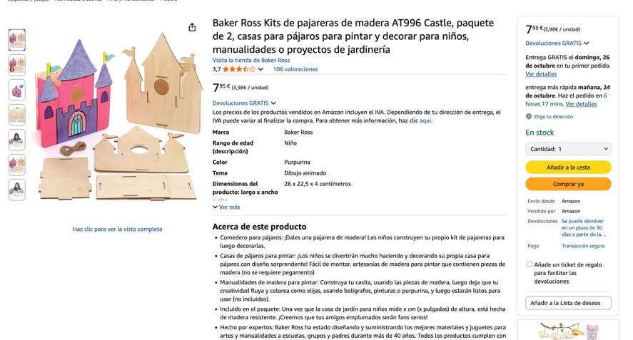

https://www.amazon.es/dp/B09B2LD3QM/ref=sspa_dk_detail_5?psc=1&pd_rd_i=B09B2LD3QM&pd_rd_w=SBIHC&content-id=amzn1.sym.0c640cbd-b6e0-461d-8cfc-a8934b5122df&pf_rd_p=0c640cbd-b6e0-461d-8cfc-a8934b5122df&pf_rd_r=0PCPESKF89RXAE6TVM5P&pd_rd_wg=eOAgI&pd_rd_r=a97ebd5e-7a82-4efe-b889-97521e8a151e&s=toys&sp_csd=d2lkZ2V0TmFtZT1zcF9kZXRhaWw

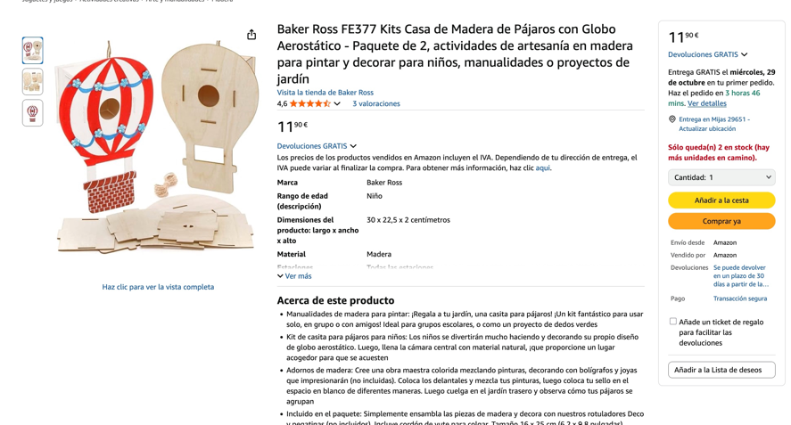

https://www.amazon.es/Baker-Ross-FE357-Madera-P%C3%A1jaros/dp/B096G8FQFL/ref=dp-upsell-widget_d_sccl_1_2/525-6698280-1605712?pd_rd_w=Jicng&content-id=amzn1.sym.7950cd44-da46-4b27-b362-872ce6b79137&pf_rd_p=7950cd44-da46-4b27-b362-872ce6b79137&pf_rd_r=WZVGAT18ZRXCKNHRENH2&pd_rd_wg=yvkXY&pd_rd_r=f12d03ec-d33d-4c61-b05f-efc34fcb060c&pd_rd_i=B096G8FQFL&psc=1

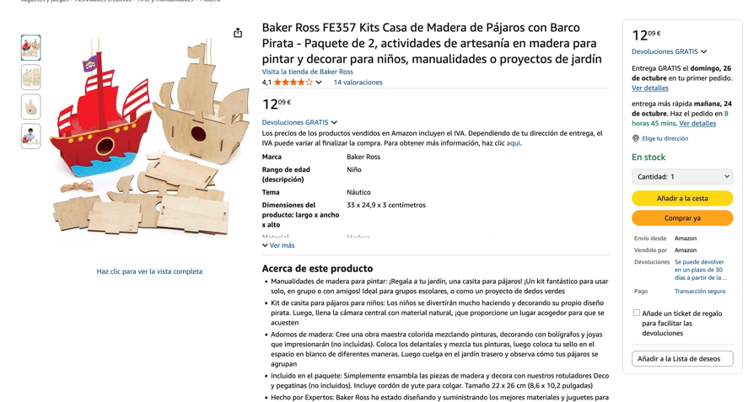

https://www.amazon.es/ORFOFE-Instrumento-Sensorial-Montessori-Desarrollo/dp/B0FNZV4QB6/ref=sr_1_52?__mk_es_ES=%C3%85M%C3%85%C5%BD%C3%95%C3%91&crid=1SV33WLBLPBUI&dib=eyJ2IjoiMSJ9.kL6twmUnweUGsIswQJ2hdpsPt0NHz-ON16Af1ucKeIAF4ZUGryT6jL3E6oeFUYlAi_ECehllp7K49RP_ilt0z4WA3-zeOcoS7W1nHNnhio2dYIsuwYAKyrtxh2UGaA6cfj0CEQWDjRxYT7uHHX3O42gdpxdoO-K-o9vhW82hS14Vm0bO_IYXOB3RBW11T7xTlXGEHGpzBzeDEi_0rHC6xinRyVwv1qgpXPQ-pZO_TDDF3D2HZobHkbt7TJ6hYRTe7DO1QRjdTlz7VQJKBX7Hza2OUZ6FJuodg_4y7bucFwg.p2eLTgjLtxqZkSP9_K10rTet7t9-07f6ay-LiWz_Cig&dib_tag=se&keywords=JUGUETE+MADERA+SIN+PINTAR&qid=1761218100&sprefix=juguete+madera+sin+pintar%2Caps%2C56&sr=8-52

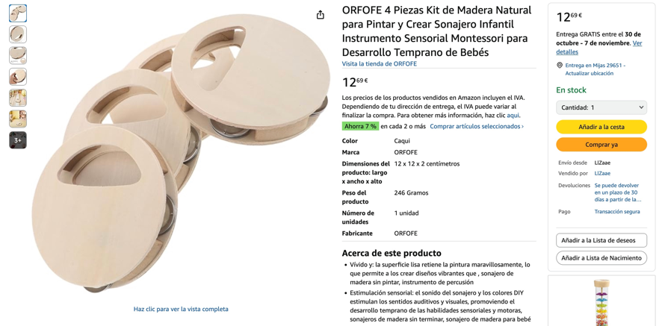

https://www.amazon.es/GETAJGHSD-12piezas-Manualidades-Creativas-Miniatura/dp/B0DPC49YPL/ref=sr_1_53?__mk_es_ES=%C3%85M%C3%85%C5%BD%C3%95%C3%91&crid=1SV33WLBLPBUI&dib=eyJ2IjoiMSJ9.kL6twmUnweUGsIswQJ2hdpsPt0NHz-ON16Af1ucKeIAF4ZUGryT6jL3E6oeFUYlAi_ECehllp7K49RP_ilt0z4WA3-zeOcoS7W1nHNnhio2dYIsuwYAKyrtxh2UGaA6cfj0CEQWDjRxYT7uHHX3O42gdpxdoO-K-o9vhW82hS14Vm0bO_IYXOB3RBW11T7xTlXGEHGpzBzeDEi_0rHC6xinRyVwv1qgpXPQ-pZO_TDDF3D2HZobHkbt7TJ6hYRTe7DO1QRjdTlz7VQJKBX7Hza2OUZ6FJuodg_4y7bucFwg.p2eLTgjLtxqZkSP9_K10rTet7t9-07f6ay-LiWz_Cig&dib_tag=se&keywords=JUGUETE+MADERA+SIN+PINTAR&qid=1761218100&sprefix=juguete+madera+sin+pintar%2Caps%2C56&sr=8-53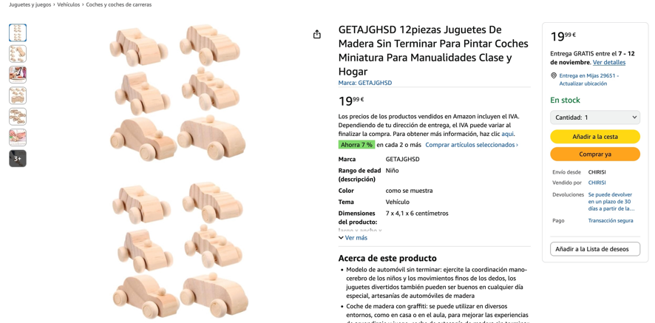

https://www.amazon.es/ibasenice-Manualidades-Juguetes-Materiales-Creatividad/dp/B0FPPV7BXH/ref=sr_1_57?__mk_es_ES=%C3%85M%C3%85%C5%BD%C3%95%C3%91&crid=1SV33WLBLPBUI&dib=eyJ2IjoiMSJ9.P3L8zj0hgGBd6wLA4CPOF0PdEKrlwrMP6h5Vrtga9ZZGIJHrDa3iLd3pQH1pIDZbdzbUD9CEhFkFM9v6oqjIv9ku5UDKbJUTpZ1sZFsC3PE.oaNCkwsRe3TtFCSIHG55NUUUbjcdRh8SBqDHdQukbqU&dib_tag=se&keywords=JUGUETE+MADERA+SIN+PINTAR&qid=1761218822&sprefix=juguete+madera+sin+pintar%2Caps%2C56&sr=8-57&xpid=pd7sfXgsMO2Gc

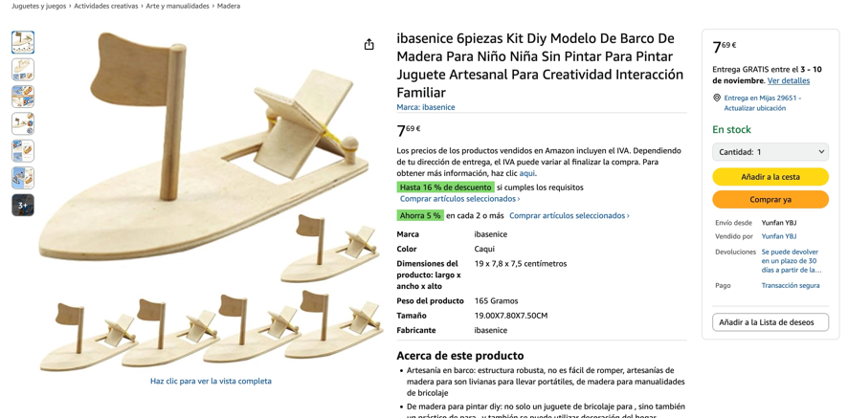

https://www.amazon.es/WEKAMOS-Manualidades-Actividades-Art%C3%ADsticas-Infantiles/dp/B0FQ41CYV2/ref=sr_1_65?__mk_es_ES=%C3%85M%C3%85%C5%BD%C3%95%C3%91&crid=1SV33WLBLPBUI&dib=eyJ2IjoiMSJ9.kPjLbsKGoCeZ5GXJ7_ptPcNNcuWqLZ455bwkimIzEn4zdKhshdpWf8zTq_L9qtV9Tpra2Q8j-tQ9RZiQSFgky2wkaa-jiT4EP7eSHhdvnIviOGsmsiqL6lD3fLHFrQQ-H_NAkZLmu0bFRBg1zOZNSVP4hEoU8gNebvVjpLB7fhzf7LmNpZBqjAYE1IteC7fj6Hr7lBPJbCXg8W_JzgsLyCxMTozB1ewAk4uiy8NjQdIgU-ThPj0hvDt09RibjsnB0M_fAVbFtgXW0oAFfK2PIWSL9UO9M8zqu5KbteI8yMQ.Klbgm032d4JuS8zRFi91xpEkdGmgdwYg8-LNpqSz3OE&dib_tag=se&keywords=JUGUETE+MADERA+SIN+PINTAR&qid=1761218822&sprefix=juguete+madera+sin+pintar%2Caps%2C56&sr=8-65&xpid=pd7sfXgsMO2Gc

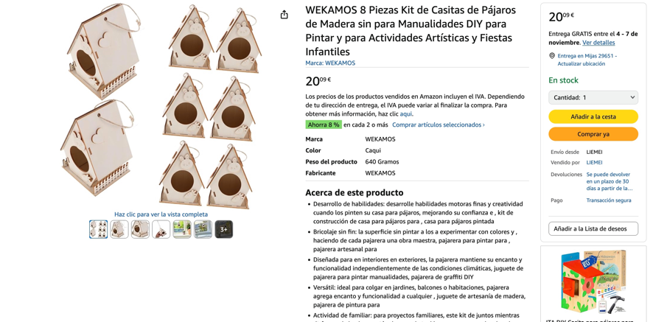

https://www.amazon.es/FRCOLOR-Serpientes-Articulaciones-Manualidades-Infantiles/dp/B0FQPQDGW4/ref=sr_1_83?__mk_es_ES=%C3%85M%C3%85%C5%BD%C3%95%C3%91&crid=1SV33WLBLPBUI&dib=eyJ2IjoiMSJ9.kPjLbsKGoCeZ5GXJ7_ptPcNNcuWqLZ455bwkimIzEn4zdKhshdpWf8zTq_L9qtV9Tpra2Q8j-tQ9RZiQSFgky2wkaa-jiT4EP7eSHhdvnIviOGsmsiqL6lD3fLHFrQQ-H_NAkZLmu0bFRBg1zOZNSVP4hEoU8gNebvVjpLB7fhzf7LmNpZBqjAYE1IteC7fj6Hr7lBPJbCXg8W_JzgsLyCxMTozB1ewAk4uiy8NjQdIgU-ThPj0hvDt09RibjsnB0M_fAVbFtgXW0oAFfK2PIWSL9UO9M8zqu5KbteI8yMQ.Klbgm032d4JuS8zRFi91xpEkdGmgdwYg8-LNpqSz3OE&dib_tag=se&keywords=JUGUETE+MADERA+SIN+PINTAR&qid=1761218822&sprefix=juguete+madera+sin+pintar%2Caps%2C56&sr=8-83&xpid=pd7sfXgsMO2Gc

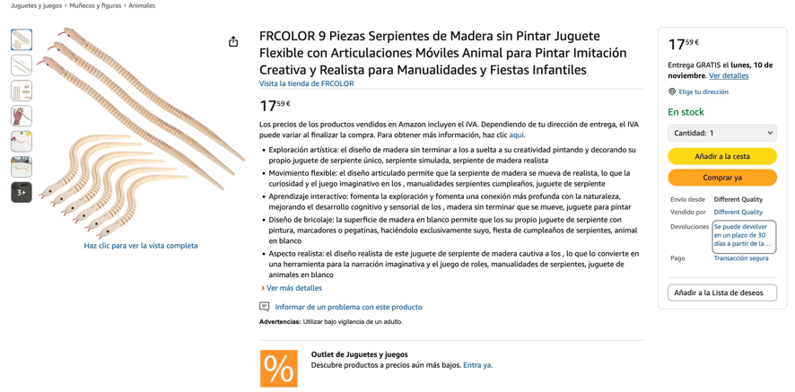

https://www.amazon.es/Hemobllo-Creativos-Superficie-Manualidades-Decoraci%C3%B3n/dp/B0FQ6MTWCP/ref=sr_1_94?__mk_es_ES=%C3%85M%C3%85%C5%BD%C3%95%C3%91&crid=1SV33WLBLPBUI&dib=eyJ2IjoiMSJ9.P3L8zj0hgGBd6wLA4CPOF0PdEKrlwrMP6h5Vrtga9ZZGIJHrDa3iLd3pQH1pIDZbdzbUD9CEhFkFM9v6oqjIv6D7qUHN5IeVr_BQ-12E_P6gCCOv9sHyoQdLUn2Y4RafcbMX0vIu8gDXg2JOYRnRjIwd6RkER7xhcaatBRTQmyRA5CRxdXXLSCx_pxCw52n626PnvGrl-hHRwzZd0odRhME8mt0qB4QegqkkkChCLaA1g6_n86VM3QoyCzcK29DBRsC80eoQ6QaGGJysFD7jrS70WJJoT-7SsKwHXsGebFk.oYlUBLL_9j2IfzrTkDAs0ujtEyCgBnbQUI7P1UwfFeQ&dib_tag=se&keywords=JUGUETE+MADERA+SIN+PINTAR&qid=1761219068&sprefix=juguete+madera+sin+pintar%2Caps%2C56&sr=8-94&xpid=pd7sfXgsMO2Gc

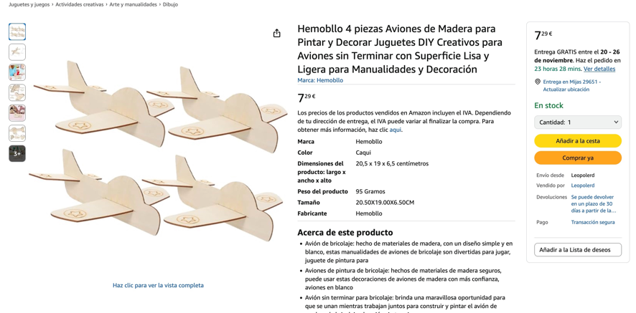

https://www.amazon.es/WOONEKY-Giratorios-Educativos-Coordinaci%C3%B3n-Habilidades/dp/B0FP5N7C86/ref=sr_1_101?__mk_es_ES=%C3%85M%C3%85%C5%BD%C3%95%C3%91&crid=1SV33WLBLPBUI&dib=eyJ2IjoiMSJ9.yWMeR2THQMdItovwHxF_NPmG91_pjLIzJgqZLLX5W_v5eqlgJyJ8aKrXKz0kB9ekxhK0cH5VDMfSJfPvNDSKTRKMwHHf0oreng1Z0OfwwLjeXJX2BO5HhSlFIL4CnnOi1qyG15AbiGEwGISrWbcVRE6kxBtWx6m5d764UT29G-r3wkLwk_619w8onApQyl8Lwv0ssK59j2KRPr--Ugk8rUdC53AtVnwMyJgbMm18TMEQnNkDkC5YWRvAqTRRBGC428cMY06hD_cliivY1GLjHa6JaIg2h8R7xuBoTZ7cYfc.yKNrh_FTRLrNJANdUY6PELZcade7dHz0HsJtxluatPs&dib_tag=se&keywords=JUGUETE+MADERA+SIN+PINTAR&qid=1761219113&sprefix=juguete+madera+sin+pintar%2Caps%2C56&sr=8-101&xpid=pd7sfXgsMO2Gc

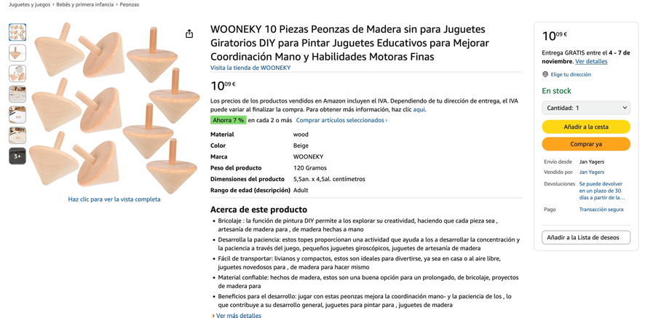

https://www.amazon.es/BESPORTBLE-Sensible-Terminar-Manualidades-Desarrollo/dp/B0FNWGZ9BD/ref=sr_1_99?__mk_es_ES=%C3%85M%C3%85%C5%BD%C3%95%C3%91&crid=1SV33WLBLPBUI&dib=eyJ2IjoiMSJ9.yWMeR2THQMdItovwHxF_NPmG91_pjLIzJgqZLLX5W_v5eqlgJyJ8aKrXKz0kB9ekxhK0cH5VDMfSJfPvNDSKTRKMwHHf0oreng1Z0OfwwLjeXJX2BO5HhSlFIL4CnnOi1qyG15AbiGEwGISrWbcVRE6kxBtWx6m5d764UT29G-r3wkLwk_619w8onApQyl8Lwv0ssK59j2KRPr--Ugk8rUdC53AtVnwMyJgbMm18TMEQnNkDkC5YWRvAqTRRBGC428cMY06hD_cliivY1GLjHa6JaIg2h8R7xuBoTZ7cYfc.yKNrh_FTRLrNJANdUY6PELZcade7dHz0HsJtxluatPs&dib_tag=se&keywords=JUGUETE+MADERA+SIN+PINTAR&qid=1761219113&sprefix=juguete+madera+sin+pintar%2Caps%2C56&sr=8-99&xpid=pd7sfXgsMO2Gc
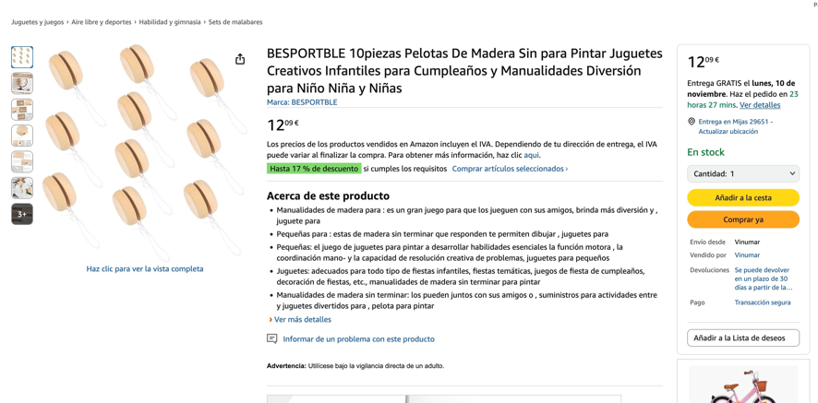

https://www.amazon.es/Sxutop-Terminar-Manualidad-Creativas-Decoraci%C3%B3n/dp/B0F9YGQ3MY/ref=sr_1_98_sspa?__mk_es_ES=%C3%85M%C3%85%C5%BD%C3%95%C3%91&crid=1SV33WLBLPBUI&dib=eyJ2IjoiMSJ9.ONAKO7pl18tXSyIjmCgsxsNoXmQZqlz19-UpJw68spkjNG3xBlgXdWHOSKwkI4BkNOYrFi5A1vYKFizYepC1GM56oXNi6J2FDDpUqgGwHfA.dofMKcQQI19GDPwFQmE5kYm8I1K1Y7aQEO2_zG-BA8c&dib_tag=se&keywords=JUGUETE+MADERA+SIN+PINTAR&qid=1761219214&sprefix=juguete+madera+sin+pintar%2Caps%2C56&sr=8-98-spons&xpid=pd7sfXgsMO2Gc&sp_csd=d2lkZ2V0TmFtZT1zcF9hdGZfbmV4dA&psc=1

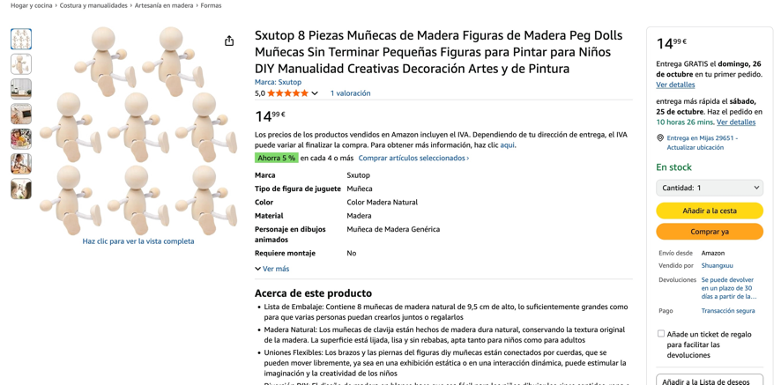

https://www.amazon.es/dp/B0FK3VPH3N/ref=sspa_dk_detail_1?psc=1&pd_rd_w=EIuhh&content-id=amzn1.sym.0c640cbd-b6e0-461d-8cfc-a8934b5122df&pf_rd_p=0c640cbd-b6e0-461d-8cfc-a8934b5122df&pf_rd_r=EZP8QF0P18D5P43Z8STS&pd_rd_wg=qlpUM&pd_rd_r=bef3d587-d819-4047-94ec-5cff9f13aa6a&sp_csd=d2lkZ2V0TmFtZT1zcF9kZXRhaWw
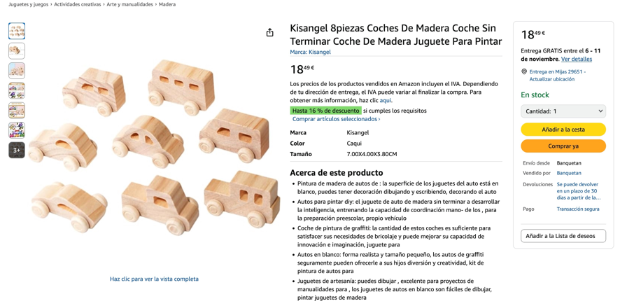

https://www.amazon.es/Manualidades-P%C3%A1jaros-Maderas-Infantiles-Pegatinas/dp/B0BZL395MP/ref=pd_rhf_dp_s_ci_mcx_mr_hp_d_d_sccl_2_8/525-6698280-1605712?pd_rd_w=nJRJD&content-id=amzn1.sym.7cab37f0-9f91-4fec-abf5-398309e3ac94:amzn1.symc.206c6295-3b43-4a2b-9d15-273ba17f7025&pf_rd_p=7cab37f0-9f91-4fec-abf5-398309e3ac94&pf_rd_r=4HEQSGXKK70Z5Z0Y4X42&pd_rd_wg=vMhxp&pd_rd_r=dc1cd238-558e-411e-b7a6-a975da375896&pd_rd_i=B0BZL395MP&psc=1

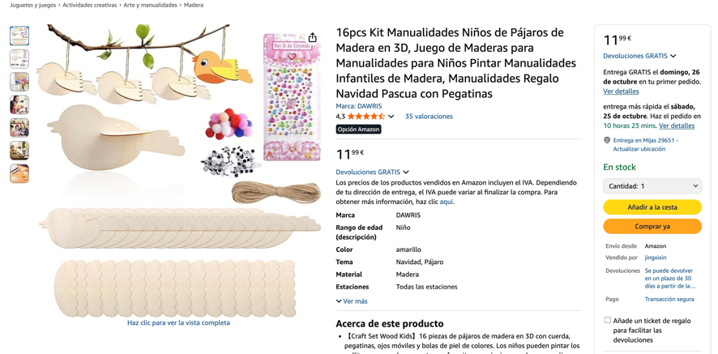

https://www.amazon.es/Ulanik-terminar-pirograf%C3%ADa-decoupage-manualidades/dp/B09BFXMQSF/ref=pd_rhf_dp_s_ci_mcx_mr_hp_d_d_sccl_2_7/525-6698280-1605712?pd_rd_w=Zmqop&content-id=amzn1.sym.7cab37f0-9f91-4fec-abf5-398309e3ac94:amzn1.symc.206c6295-3b43-4a2b-9d15-273ba17f7025&pf_rd_p=7cab37f0-9f91-4fec-abf5-398309e3ac94&pf_rd_r=91WEN0ZE1QVWACRH2HHM&pd_rd_wg=jsK2D&pd_rd_r=0b753f17-05b1-45ec-a409-d79056784019&pd_rd_i=B09BFXMQSF&psc=1

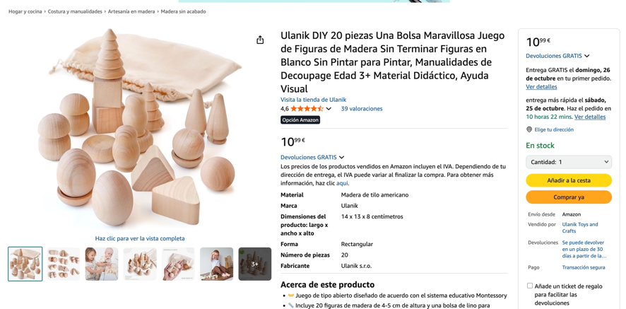

https://www.amazon.es/%C3%81rboles-Manualidades-Decoraciones-Naturales-Fiestas/dp/B0CFXX8VFS/ref=vse_cards_0?_encoding=UTF8&pd_rd_w=IN1Wr&content-id=amzn1.sym.111b67bb-164c-4dcd-b034-d7b097399a3c&pf_rd_p=111b67bb-164c-4dcd-b034-d7b097399a3c&pf_rd_r=V8H4GT3HK3PD8F6RQ75F&pd_rd_wg=I0Hf7&pd_rd_r=95d5bed2-e150-4356-9148-6824775e18ed

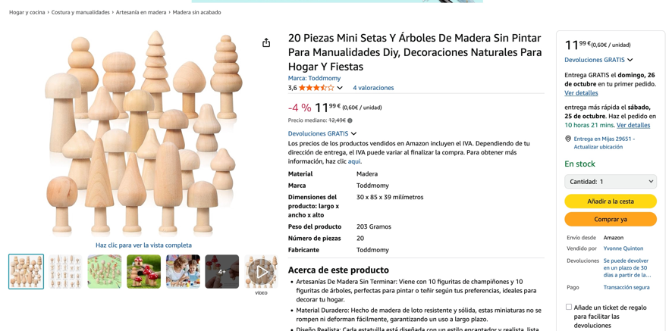

https://www.amazon.es/iplusmile-Transporte-Manualidades-Decoraci%C3%B3n-Educativos/dp/B0FLHJQJ9N/ref=pd_rhf_dp_s_ci_mcx_mr_hp_d_d_sccl_2_6/525-6698280-1605712?pd_rd_w=5PcA4&content-id=amzn1.sym.7cab37f0-9f91-4fec-abf5-398309e3ac94:amzn1.symc.206c6295-3b43-4a2b-9d15-273ba17f7025&pf_rd_p=7cab37f0-9f91-4fec-abf5-398309e3ac94&pf_rd_r=EE6Z0J5N3R4K3FQ5EX4F&pd_rd_wg=2yIdy&pd_rd_r=27457db9-6e12-460e-b780-daaca0ca7cd3&pd_rd_i=B0FLHJQJ9N&psc=1
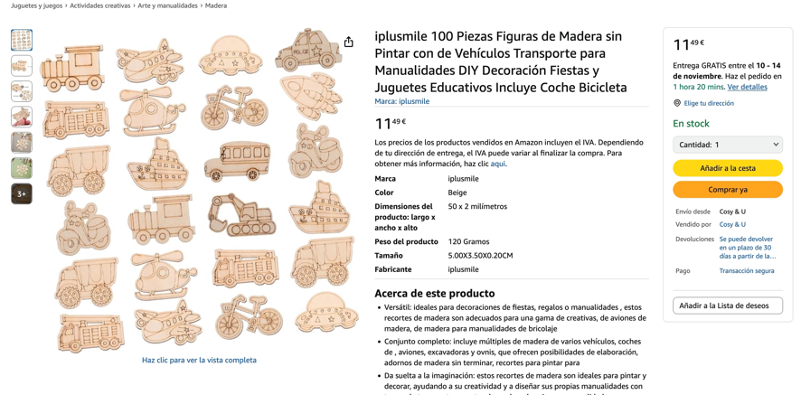

https://www.amazon.es/Peque%C3%B1a-casa-madera-para-decorar/dp/B08HK1R2S1/ref=dp_fod_d_sccl_2/525-6698280-1605712?pd_rd_w=moySK&content-id=amzn1.sym.7f8c3e11-d5c3-442e-8664-b6df69ee72fb&pf_rd_p=7f8c3e11-d5c3-442e-8664-b6df69ee72fb&pf_rd_r=RG99NCQY8B7KGV430K6K&pd_rd_wg=ojray&pd_rd_r=fa4ca759-7fec-4b48-af48-f66bdcb70f6f&pd_rd_i=B08HK1R2S1&psc=1

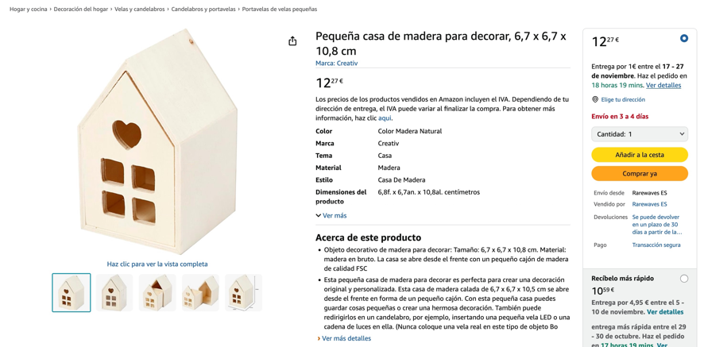

https://www.amazon.es/dp/B07DCWKK6X/ref=sspa_dk_detail_3?pd_rd_i=B07DCWKK6X&pd_rd_w=PZvoX&content-id=amzn1.sym.9611f95a-c40b-4189-92ca-0b4d34f94371&pf_rd_p=9611f95a-c40b-4189-92ca-0b4d34f94371&pf_rd_r=JAGKD7SGZP9HE8RE7K15&pd_rd_wg=a9du1&pd_rd_r=daeb95b2-b9d3-45c3-a514-6d2b0e73e120&sp_csd=d2lkZ2V0TmFtZT1zcF9kZXRhaWxfdGhlbWF0aWM&th=1

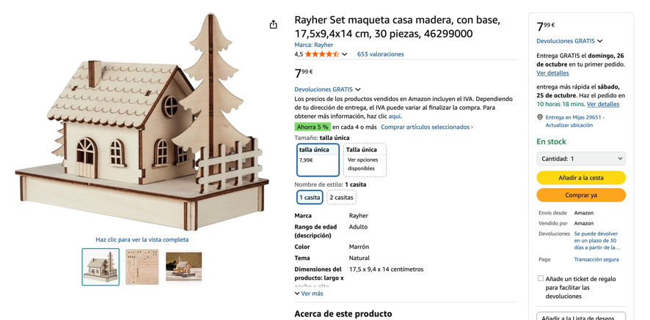

https://www.amazon.es/dp/B013DP3BY0/ref=sspa_dk_detail_0?pd_rd_i=B013DP3BY0&pd_rd_w=N4LWz&content-id=amzn1.sym.0c640cbd-b6e0-461d-8cfc-a8934b5122df&pf_rd_p=0c640cbd-b6e0-461d-8cfc-a8934b5122df&pf_rd_r=WXBJYBZVQSHFQDFGE2DR&pd_rd_wg=abWqY&pd_rd_r=cc9e4f60-26b6-4977-a90e-6db7b625ad0b&sp_csd=d2lkZ2V0TmFtZT1zcF9kZXRhaWw&th=1

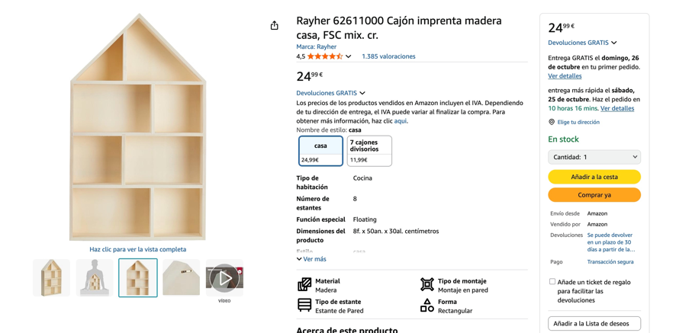

https://www.amazon.es/dp/B0CV13PZPK/ref=sspa_dk_detail_4?psc=1&pd_rd_i=B0CV13PZPK&pd_rd_w=w3aR4&content-id=amzn1.sym.0c640cbd-b6e0-461d-8cfc-a8934b5122df&pf_rd_p=0c640cbd-b6e0-461d-8cfc-a8934b5122df&pf_rd_r=JAGKD7SGZP9HE8RE7K15&pd_rd_wg=a9du1&pd_rd_r=daeb95b2-b9d3-45c3-a514-6d2b0e73e120&sp_csd=d2lkZ2V0TmFtZT1zcF9kZXRhaWw

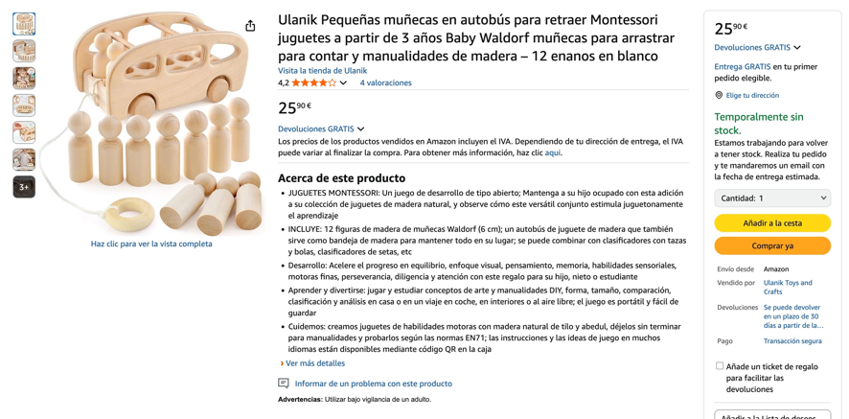

https://www.amazon.es/Artemio-Figuras-decorativas-casetas-unidades/dp/B00NGRO39S/ref=pd_rhf_dp_s_ci_mcx_mr_hp_d_d_sccl_1_19/525-6698280-1605712?pd_rd_w=kbOzM&content-id=amzn1.sym.7cab37f0-9f91-4fec-abf5-398309e3ac94:amzn1.symc.206c6295-3b43-4a2b-9d15-273ba17f7025&pf_rd_p=7cab37f0-9f91-4fec-abf5-398309e3ac94&pf_rd_r=E39AWQJR7QJQSWDXX1G9&pd_rd_wg=RvDAe&pd_rd_r=4102565e-1fe0-4206-b490-1b796586a864&pd_rd_i=B00NGRO39S&psc=1

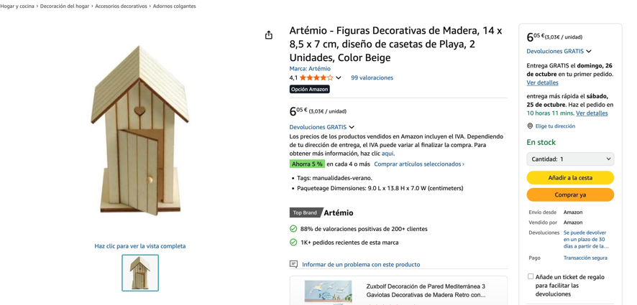

https://www.amazon.es/Toddmomy-Figuras-Manualidades-Sencillas-Peque%C3%B1os/dp/B0CQXCBFW3/ref=pd_rhf_dp_s_ci_mcx_mr_hp_d_d_sccl_1_23/525-6698280-1605712?pd_rd_w=kbOzM&content-id=amzn1.sym.7cab37f0-9f91-4fec-abf5-398309e3ac94%3Aamzn1.symc.206c6295-3b43-4a2b-9d15-273ba17f7025&pf_rd_p=7cab37f0-9f91-4fec-abf5-398309e3ac94&pf_rd_r=E39AWQJR7QJQSWDXX1G9&pd_rd_wg=RvDAe&pd_rd_r=4102565e-1fe0-4206-b490-1b796586a864&pd_rd_i=B0CQXCBFW3&th=1
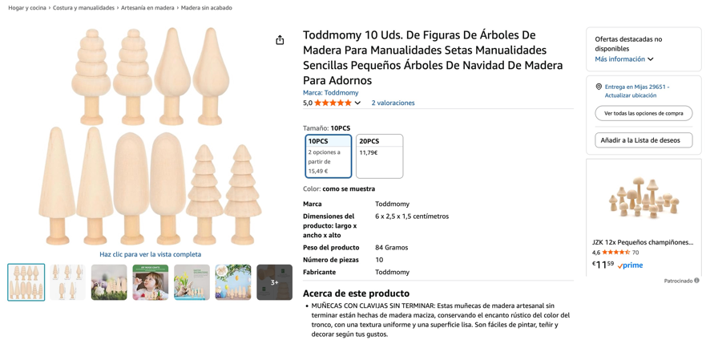

https://www.amazon.es/dp/B0CZX5B6MT/ref=sspa_dk_detail_5?psc=1&pf_rd_p=0c640cbd-b6e0-461d-8cfc-a8934b5122df&pf_rd_r=GW31TCXS9TNKEZVR6TC1&pd_rd_wg=UcznQ&pd_rd_w=MtRag&content-id=amzn1.sym.0c640cbd-b6e0-461d-8cfc-a8934b5122df&pd_rd_r=69f23264-28d1-4dce-ba90-8a8a85bf4b66&sp_csd=d2lkZ2V0TmFtZT1zcF9kZXRhaWw

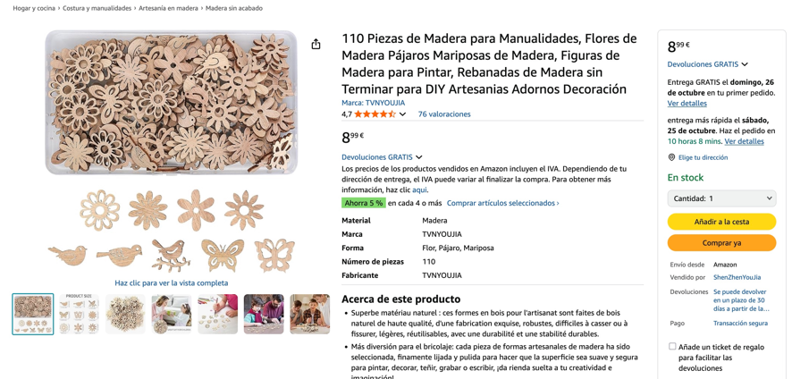

https://www.amazon.es/dp/B0DPMWDC2R/ref=sspa_dk_detail_2?psc=1&pd_rd_i=B0DPMWDC2R&pd_rd_w=NvjBF&content-id=amzn1.sym.0c640cbd-b6e0-461d-8cfc-a8934b5122df&pf_rd_p=0c640cbd-b6e0-461d-8cfc-a8934b5122df&pf_rd_r=0G82Z16J03TZZD2DW890&pd_rd_wg=Lc9TV&pd_rd_r=23ae621f-4042-477a-a98f-c5aecd024cbb&sp_csd=d2lkZ2V0TmFtZT1zcF9kZXRhaWw

